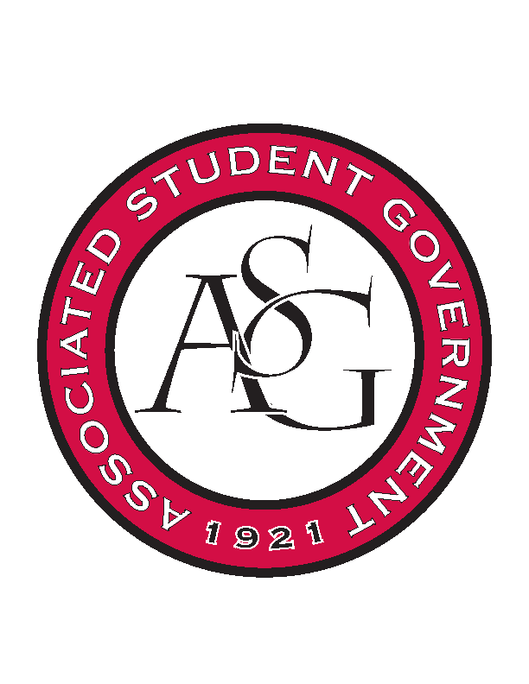
Associated Student Government

Office of Financial Affairs Meeting Minutes
April 19, 2018

- Call To Order
- Roll Call
  - Adam Jones
  - Colin Gonzalez
  - Jalen Hemphill
  - Kyle Ward
  - Peyton Podschwit
  - Ploy Pleetissamuth
      - Kate
  - Semien Hagos
  - Sofia Hadley
  - William Neely
Proxies
  - Dani Zapata
  - Kate Hedgecock
  - Madeline Brown
  - Marco Gargano
  - Kadarius
- Approval of the Minutes
- Appeals
- Audit Reports
- Old Business
  - Phi Sigma Rho
      - Second round approved (9-0)
  - UARK Gaming
      - Second round approved (9-0)
  - Greek Life Budget Portal - Zeta Phi Beta - Regional Conference
      - Second round approved (7-2)
  - Greek Life Budget Portal - Zeta Phi Beta - Admin Funds
      - Second round approved (5-4)
        - Cut extra things (5-4)
        - approved paying only for registration fees (9-0)
  - International Justice Mission at the University of Arkansas
      - Second round approved (9-0)
  - Theta Tau
      - Second round approved (9-0)
- New Business
  - Alpha Epsilon Delta
      - More clarification on what the speaker is talking about
      - Ask for agenda
      - Clarify how it’s not recruitment
      - Approved (9-0)
  - Biological Engineering Student Club
      - Breakdown has more than $100
      - Approved (9-0)
  - Greek Life Budget Portal - Zeta Phi Beta - Regional Conference
      - Denied (9-0)
  - ALPFA
      - We are approving them with this amount
      - Approved as it is (9-0)
  - Full Stomachs Clean Feet
      - Ask for an invoice
      - Name the speakers
      - Add emails
      - Add mandatory advertising
      - Ask how they plan on getting 65 people to attend
      - Ask about amount of chicken
      - Approved (9-0)
  - Electrochemical Society - University of Arkansas student chapter
      - What is the delivery fee?
      - Why so many pizzas
      - Itemized list
      - Approved (9-0)
- Announcements
  - Remember to do audits!
- Adjournment

