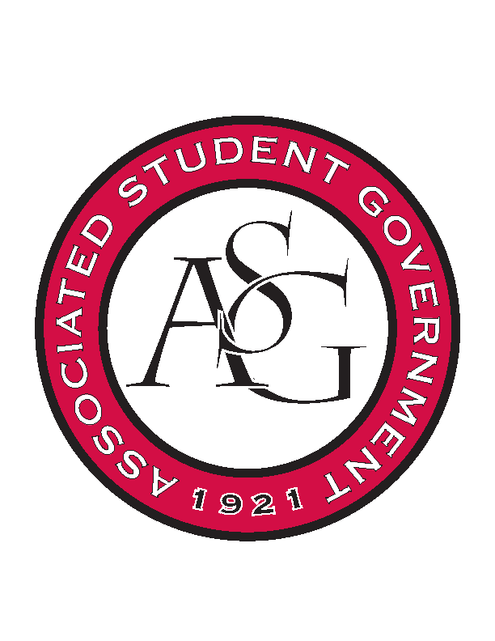
Associated Student Government

Office of Financial Affairs Meeting Agenda
April 26, 2018

- Call To Order
- Roll Call
  - Adam Jones
      - Proxy: Kate Hedgecock
  - Colin Gonzalez
  - Jalen Hemphill
      - Proxy: Madeline Brown
  - Kyle Ward
  - Peyton Podschwit
  - Ploy Pleetissamuth
  - Semien Hagos
      - Absent
  - Sofia Hadley
  - William Neely
Proxies
  - Dani Zapata
  - Kate Hedgecock
  - Madeline Brown
  - Marco Gargano
  - Kadarius
- Approval of the Minutes
- Appeals
- Audit Reports
- Old Business
  - Alpha Epsilon Delta
      - Second round approved (6-0)
  - Biological Engineering Student Club
      - Second round approved (6-0)
  - ALPFA
      - Second round approved (6-0)
  - Full Stomachs Clean Feet
      - Second round approved (7-0)
  - Electrochemical Society - University of Arkansas student chapter
      - It will be 24 pizzas at $4.99
      - New total will be 119.76
      - Will have to pick the pizzas up
      - Second round approved (second round approved 8-0)
- New Business
  - National Residence Hall Honorary
      - When is the due date?
      - Is there proof that you can pay on-site?
      - How much does it cost?
      - Approved (8-0)
  - ALPFA – additional student to the same conference
      - Approved (8-0)
  - Caribbean Student Association
      - Let them know about the $50 next time
      - Approve at the $20
      - Approved (8-0)
  - Alpha Chi Sigma
      - If paid by May 15 it will be $100
      - Approved (8-0)
  - Minorities in Agriculture, Natural Resources, and Related Sciences
      - Recruitment
      - They need to cut budget to $150
      - Cannot fund the banner
      - Need a more itemized list
      - Do they need to pay a fee for the Agri Park?
      - Why are you having the recruitment event off campus?
      - Approved (8-0)
  - Creative Writing Club
      - Outside of the funding rounds
      - Can keep the admin – approved (8-0)
      - Denied (7-0-1)
  - IEEE Power Electronics Society
      - The pizza may be over priced
      - Need a more itemized list/invoice
      - Will the speaker be given an honorarium?
      - Are there any co-sponsors?
      - How will you make sure that this event is not exclusive to the RSO?
      - Approved (5-3)
  - Hispanic Law Student Association
      - Approved (7-0)
  - Il Circolo Italiano
      - Approved (8-0)
  - Residents Interhall Congress
      - Tabled (8-0)
  - Razorback Twirlers
      - Denied (8-0)
      - Not educational
  - Alpha Lambda Delta
      - What snacks?
      - Denied (8-0)
      - Apply for next round
  - ALPFA – Recruitment
      - Denied (8-0)
      - Apply for next round
  - Phi Alpha Delta
      - Verify the price and due date
      - Approved (8-0)
  - American Institute of Architecture Students
      - APPROVED (8-0)
  - Army ROTC
      - 5AM-7AM?
      - Airforce ROTC contributing? (What the price????)
      - One 46$ per diem
      - Approved (8-0)
  - UARK Gaming – Admin Funds
      - Approved (8-0)
  - Camp Kesem
      - Approved (8-0)
  - Russian-Eurasian Student Organization
      - More info on flights???
      - Agenda please
      - Dets on dat speaker
      - Approvesd (8-0)
  - Greek Life Budget Portal - Sigma Iota Alpha Conference and Admin supplies
      - Cannot fund this because presence of alcohol?
      - Tabled (8-0)
      - Admin- Approved (8-0)
  - Beta Psi Omega
      - More info on how they will dumb it down
      - Where do they plan on getting that sheet from?
      - Approved (8-0)
  - Contemporary Sculpture Society
      - Why two nights?
      - Cut studio critiques?
      - Is the art department co sponsoring this?
      - Approved (7-1)
  - UARK Gaming – Recruitment
      - Approved (8-0)
  - Alpha Chi Sigma
      - Approved (8-0)
  - Razorback Relay For Life
      - Is spaced reserved?
      - How is the food being cooked?
      - Approved (8-0)
- Announcements
  - Remember to do audits!

- Adjournment

