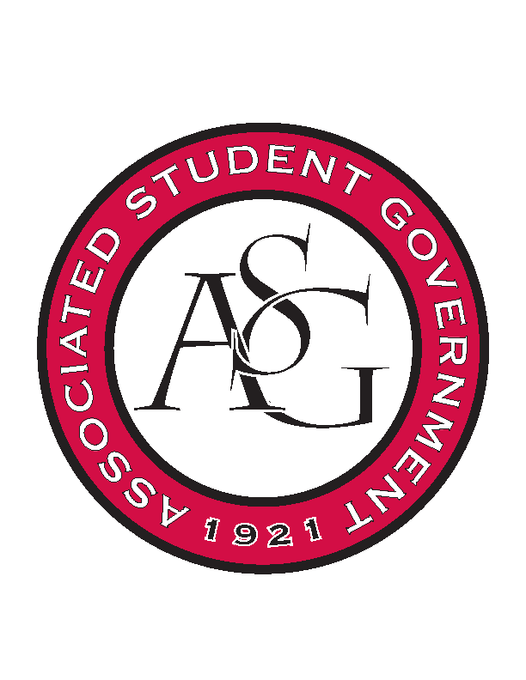
Associated Student Government

Office of Financial Affairs Meeting Agenda
May 3, 2018

- Call To Order
- Roll Call
  - Adam Jones – present
  - Colin Gonzalez-present
  - Jalen Hemphill – present
  - Kyle Ward – present
  - Peyton Podschwit –Proxy Madeline Brown @ 5:12 pm; Peyton arrived 5:16 pm – Madeline no longer proxying for any Board Member.
  - Ploy Pleetissamuth – Madeline Brown proxy 5:00 pm -5:12 pm
  - Semien Hagos – present
  - Sofia Hadley-present
  - William Neely – present
Proxies
  - Dani Zapata
  - Kate Hedgecock
  - Madeline Brown – present
  - Marco Gargano
  - Kadarius
- Approval of the Minutes
- Appeals
- Audit Reports
- Old Business
  - National Residence Hall Honorary
      - Denied – 8-0

  - ALPFA – additional student to the same conference
      - Approved 8-0
  - Caribbean Student Association
      - Approved 8-0
  - Alpha Chi Sigma
      - Approved 8-0
  - Minorities in Agriculture, Natural Resources, and Related Sciences
      - Funding @ $113.45
      - Have to fund 2L bottles versus cans
      - Approved 8-0
  - Creative Writing Club
      - Approved 8-0
  - IEEE Power Electronics Society
      - Approved 8-0
  - Hispanic Law Student Association
      - Approved 8-0
  - Il Circolo Italiano
      - Approved 8-0
  - Phi Alpha Delta
      - $300 approved
      - Approved 9-0

  - American Institute of Architecture Students
      - Approved 9-0
  - Army ROTC
      - Stadium Discussion (because the location isn’t secured/booked)
      - Location is not confirmed – locations cannot be TBD
      - Denied 9-0
  - UARK Gaming – Admin Funds
      - Approved 9-0
  - Camp Kesem
      - Approved 9-0
  - Russian-Eurasian Student Organization
      - Approved 9-0
  - Greek Life Budget Portal - Sigma Iota Alpha Conference and Admin supplies
      - Admin- Approved 9-0
      - Conference – Approved 9-0
        - $85 rate
  - Beta Psi Omega
      - Approved 9-0
  - Contemporary Sculpture Society
      - Cut to 1 night
      - Approved 9-0
  - UARK Gaming – Recruitment
      - Approved 8-1
  - Alpha Chi Sigma
      - Approved 9-0
  - Razorback Relay For Life
      - Add American Cancer Society as co-sponsor
      - Approved 9-0
- Announcements
  - Remember to fill out your audits!
- Adjournment

