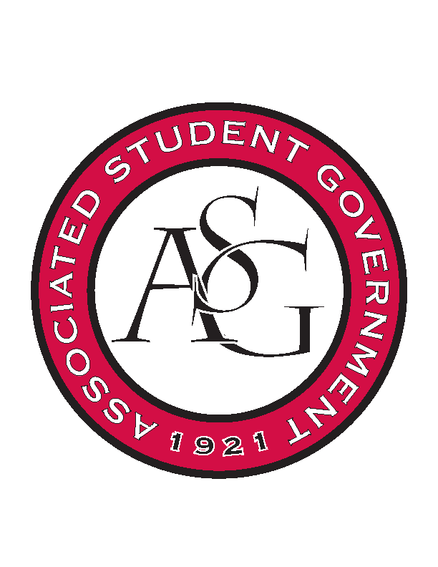
Associated Student Government

Office of Financial Affairs Meeting Agenda
October 11th, 2018

- Call To Order
- Roll Call
  - Adam Corral
  - Colin Gonzalez
  - Emily Richey
  - Kirsten James
  - Madeline Brown
  - Ploy Pleetissamuth
  - Sofia Hadley
  - William Neely
  - Zachary Keating
Proxies
  - Alexis Valdes
  - Brittany Fulmer
  - Nicholas Foster
  - Sally Gairhan
- Approval of the Minutes
- Appeals
  - Saudi Students Club
- Audit Reports
- Old Business
  - Alpha Kappa Delta
  - The Higher Education Organization
  - Russian-Eurasian Student Organization
  - African Students Organization
- New Business
  - Panamanian Student Organization
  - Chi Alpha
  - oSTEM at University of Arkansas
  - Students for a Free Tibet
  - International Students Organization
  - Stand Up for Reproductive Rights and Gender Equity
  - Vietnamese Student Association
  - UARK Music Performers Producers & Professionals
  - Alpha Iota Rho
  - Board of Advocates
  - Biology Graduate Student Association
- Announcements
- Adjournment

