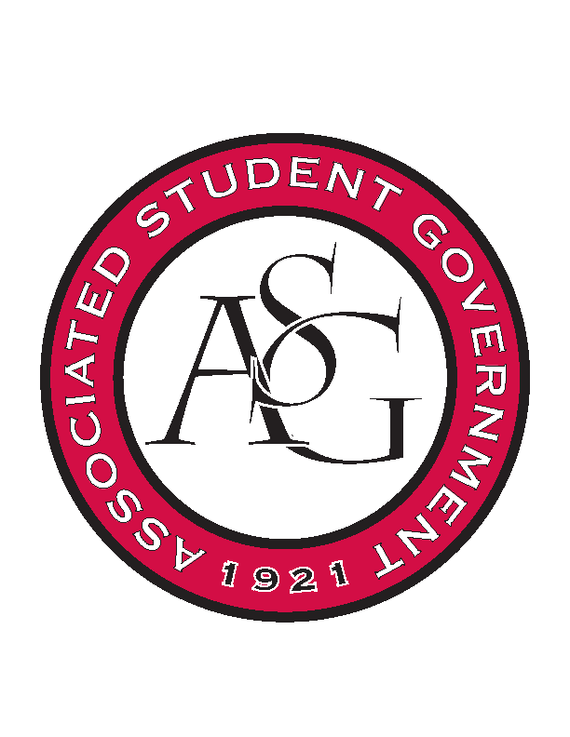
Associated Student Government

Office of Financial Affairs Meeting Agenda
October 17th, 2018

- Call To Order
- Roll Call
  - Adam Corral
  - Colin Gonzalez
  - Emily Richey
  - Kirsten James
  - Madeline Brown
  - Ploy Pleetissamuth
  - Sofia Hadley
  - William Neely
  - Zachary Keating
Proxies
  - Alexis Valdes
  - Brittany Fulmer
  - Nicholas Foster
  - Sally Gairhan
- Approval of the Minutes
- Appeals
- Audit Reports
  - Nick Foster – Chinese Students and Scholars Association
  - Colin Gonzalez – Chinese Students and Scholars Association
  - Kirsten James – Razorback Booster Club
- Old Business
  - Panamanian Students Organization
  - Chi Alpha
  - oSTEM at the University of Arkansas
  - Students for a Free Tibet
  - International Students Organization
  - Stand Up for Reproductive Rights and Gender Equity
  - UARK Music Performers Producers and Professionals
  - Biology Graduate Student Association
  - Millicent Nkirote Gikunda – Individual Conference
- New Business
  - Electrochemical Society - University of Arkansas student chapter
  - Biology Club
  - Japanese Student Association
  - Vietnamese Student Association
  - Inspirational Chorale
  - Graduate Society of Women Engineers at the University of Arkansas
  - Black Law Students Association
  - Walton College Finance Association
- Announcements
- Adjournment

