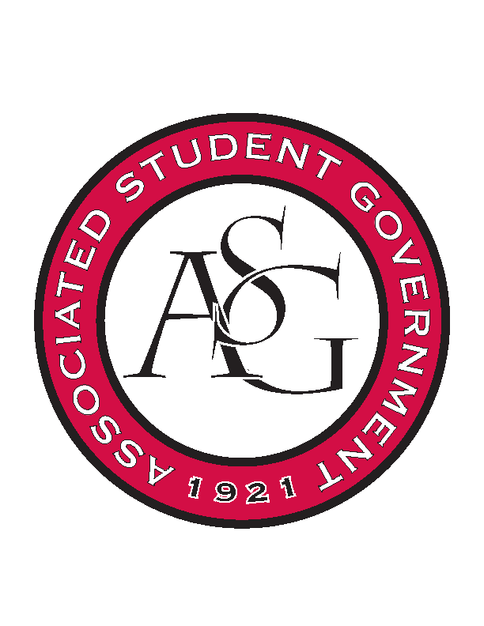
Associated Student Government

Office of Financial Affairs Meeting Agenda
October 25th, 2018

- Call To Order
- Roll Call
  - Adam Corral
  - Colin Gonzalez
  - Emily Richey
  - Kirsten James
  - Madeline Brown
  - Ploy Pleetissamuth
  - Sofia Hadley
  - William Neely
  - Zachary Keating
Proxies
  - Alexis Valdes
  - Brittany Fulmer
  - Nicholas Foster
  - Sally Gairhan
- Approval of the Minutes
- Appeals
- Audit Reports
  - Kirsten James – Razorback Booster Club, Student Alumni Association
  - Sally Gairhan – Beta Psi Omega
  - Brittany Fulmer – Alpha Chi Sigma
  - Emily Richey – Alpha Chi Sigma
- Old Business
  - Electrochemical Society - University of Arkansas student chapter
  - Biology Club
  - Japanese Student Association
  - Vietnamese Student Association
  - Inspirational Chorale
- New Business
  - Psychology Club
  - Engineering Safety
  - American Marketing Association
  - Advertising Club
  - Fulbright Scholars at the University of Arkansas
  - Students of Retailing Excellence
  - Drawing and Painting Association
  - Greek Life Budget Portal
  - American Society of Civil Engineers
- Dinner Break
- Standing Rules Meeting Called to Order
- Announcements
- Adjournment

