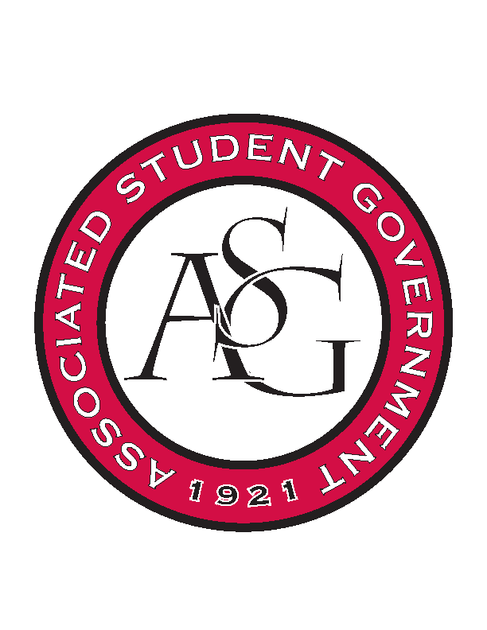
Associated Student Government

Office of Financial Affairs Meeting Agenda
November 1st, 2018

- Call To Order
- Roll Call
  - Adam Corral
  - Colin Gonzalez
  - Emily Richey
  - Kirsten James
  - Madeline Brown
  - Ploy Pleetissamuth
  - Sofia Hadley
  - William Neely
  - Zachary Keating
Proxies
  - Alexis Valdes
  - Brittany Fulmer
  - Nicholas Foster
  - Sally Gairhan
- Approval of the Minutes
- Appeals
  - Vietnamese Students Association
  - Biology Club – tabled
- Audit Reports

- Old Business
  - Fulbright Scholars at the University of Arkansas
  - Greek Life Budget Portal
- New Business
  - Christian Graduate Student Fellowship
  - American Society of Civil Engineers
  - Muslim Students Association
  - Students of Retailing Excellence
  - CRU
  - Eta Sigma Gamma
  - Undergraduate Mock Trial
- Second Round of Standing Rules
- Announcements
- Adjournment

