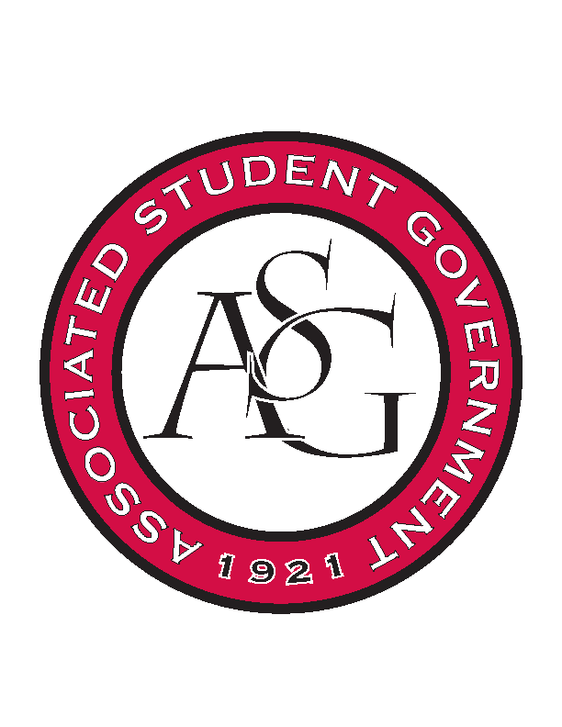
Associated Student Government

Office of Financial Affairs Meeting Agenda
November 15, 2018

- Call To Order
- Roll Call
  - Adam Corral
  - Colin Gonzalez
  - Emily Richey
  - Kirsten James
  - Madeline Brown
  - Ploy Pleetissamuth
  - Sofia Hadley
  - William Neely
  - Zachary Keating
Proxies
  - Alexis Valdes
  - Brittany Fulmer
  - Nicholas Foster
  - Sally Gairhan
- Approval of the Minutes
- Appeals
- Audit Reports
- Old Business
  - Association of Ceramic Enthusiasts
  - Horticulture Club
- New Business
  - UARK Gaming
  - Association of Ceramic Enthusiasts
- FRIENDSGIVING
- Announcements
- Adjournment

