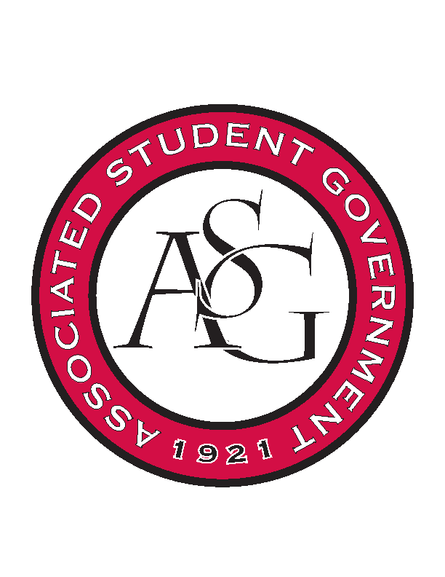
Associated Student Government

Office of Financial Affairs Meeting Agenda
November 29, 2018

- Call To Order
- Roll Call
  - Adam Corral
  - Colin Gonzalez
  - Emily Richey
  - Kirsten James
  - Madeline Brown
  - Ploy Pleetissamuth
  - Sofia Hadley
  - William Neely
  - Zachary Keating
Proxies
  - Alexis Valdes
  - Brittany Fulmer
  - Nicholas Foster
  - Sally Gairhan
- Approval of the Minutes
- Appeals
- Audit Reports
  - Sally Gairhan - Inspirational Chorale, Japanese Students Association, Power and Privilege
  - Brittany Fulmer – Japanese Students Association
  - Colin Gonzalez – Students for a Free Tibet, Friends of India
  - Madeline Brown – Panamanian Student Organization, Power and Privilege
  - Sofia Hadley – Panamanian Student Organization
- Old Business
    - Association of Ceramic Enthusiasts
- New Business
  - Chinese Students and Scholars Association
  - Alpha Epsilon Delta60
  - Black Law Students Association
  - Chi Sigma Alpha
- Announcements
- Adjournment

