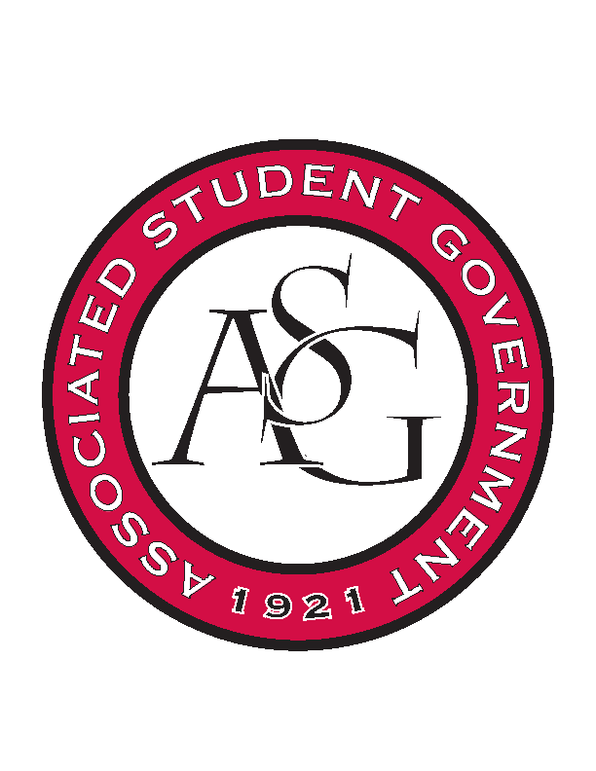
Associated Student Government

Office of Financial Affairs Meeting Agenda
August 22, 2018

- Call To Order
- Roll Call
  - Adam Corral
  - Colin Gonzalez
  - Emily Richey
  - Kirsten James
  - Madeline Brown
  - Ploy Pleetissamuth
  - Sofia Hadley
  - William Neely
  - Zachary Keating
Proxies
  - Alexis Valdes
  - Brittany Fulmer
  - Nicholas Foster
  - Sally Gairhan
- Approval of the Minutes
- Appeals
  - None
- Audit Reports
  - None
- Introductions
- Office of Financial Affairs Overview
- Viewpoint Neutrality Training
- Hogsync Expectations/Process
- OFA Expectations/Roles
- Peer to Peer – Returners Experiences
  - Returning OFA Board Members
- Old Business
  - None
- New Business
  - Residents Interhall Congress
  - Chinese Students Association
  - Society of Hispanic Professional Engineers
  - Phi Delta Theta - Admin Supplies
  - Razorback Booster Club
  - Razorback Booster Club
- Announcements
- Adjournment

