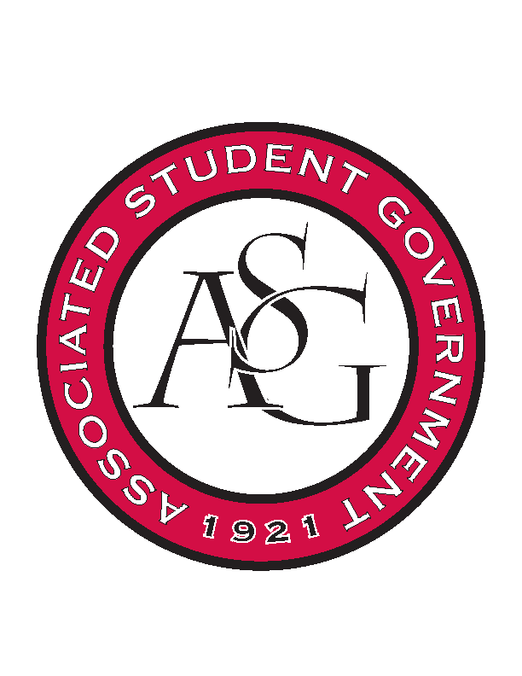
Associated Student Government

Office of Financial Affairs Meeting Agenda
August 30th, 2018

- Call to Order
- Take OFA Pictures for ASG Website
- Roll Call
  - Adam Corral
  - Colin Gonzalez
  - Emily Richey
  - Kirsten James
  - Madeline Brown
  - Ploy Pleetissamuth
  - Sofia Hadley
  - William Neely
  - Zachary Keating
Proxies
  - Alexis Valdes
  - Brittany Fulmer
  - Nicholas Foster
  - Sally Gairhan
- Approval of the Minutes
- Appeals
  - None
- Audit Reports
  - None
- Old Business
  - Residents Interhall Congress
  - Chinese Students Association
  - Society of Hispanic Professional Engineers
  - Phi Delta Theta - Admin Supplies
  - Razorback Booster Club
  - Razorback Booster Club
- New Business
  - Geo-Institute Graduate Student Organization
  - Iranian Students Association
  - Space and Planetary Association for Collaboration and Education Hogs
  - The Higher Education Organization – NODA Conference
  - The Higher Education Organization – TACUSPA Conference
  - Technology and Engineering Education Collegiate Association
  - Tau Beta Pi
  - Anthropology Graduate Student Consortium
- Announcements
- Adjournment

