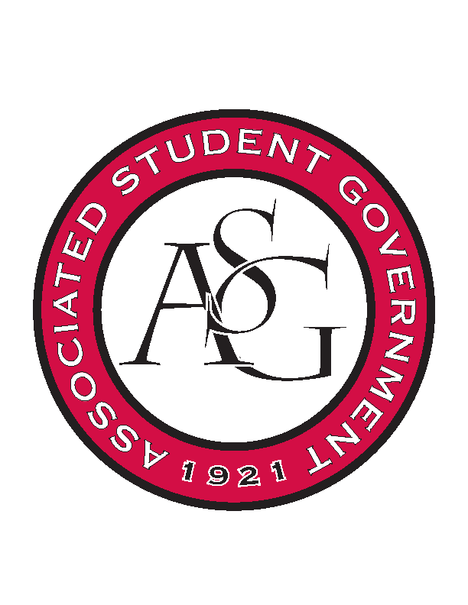
Associated Student Government

Office of Financial Affairs Meeting Agenda
September 13th, 2018

- Call to Order
- Roll Call
  - Adam Corral
  - Colin Gonzalez
  - Emily Richey
  - Kirsten James
  - Madeline Brown
  - Ploy Pleetissamuth
  - Sofia Hadley
  - William Neely
  - Zachary Keating
Proxies
  - Alexis Valdes
  - Brittany Fulmer
  - Nicholas Foster
  - Sally Gairhan
- Approval of the Minutes
- Appeals
  - None
- Audit Reports
  - None
- Old Business
  - Greek Life Budget Portal
  - Society of Hispanic Professional Engineers
  - Crop, Soil, and Environmental Sciences Undergraduate Club
  - The Higher Education Organization
  - Society of Women Engineers
- New Business
  - Iranian Students Association
  - Graduate Society of Women Engineers at the University of Arkansas
  - Caribbean Student Association
  - Food Science Club
  - Contemporary Sculpture Society
  - Biomedical Engineering Society
  - The Higher Education Organization
- Announcements
- Adjournment

