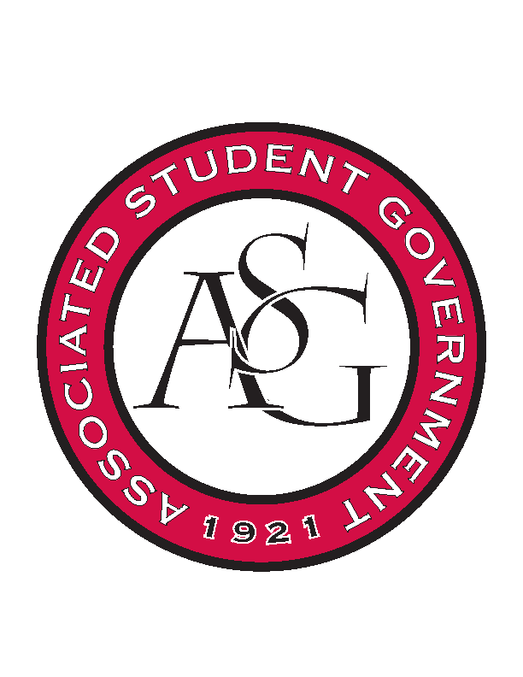
Associated Student Government

Office of Financial Affairs Meeting Agenda
September 20th, 2018

- Call To Order
- Roll Call
  - Adam Corral
  - Colin Gonzalez
  - Emily Richey
  - Kirsten James
  - Madeline Brown
  - Ploy Pleetissamuth
  - Sofia Hadley
  - William Neely
  - Zachary Keating
Proxies
  - Alexis Valdes
  - Brittany Fulmer
  - Nicholas Foster
  - Sally Gairhan
- Approval of the Minutes
- Appeals
- Audit Reports
- Old Business
  - Graduate Society of Women Engineers at the University of Arkansas
  - Caribbean Student Association
  - Food Science Club
  - Contemporary Sculpture Society
  - Student Alumni Association
- New Business
  - National Society of Black Engineers
  - Iranian Students Association
  - The Higher Education Organization – Molly Kinder
  - The Higher Education Organization - Carly Waschka
  - International Bolivian Organization
  - The Higher Education Organization – Lauren Hughes
  - The Higher Education Organization – Angelique Price
  - InterVarsity Christian Fellowship
  - Lambda Alpha Epsilon
  - Federalist Society
  - ALPFA
  - oSTEM at University of Arkansas
  - Alpha Chi Sigma
  - Friends of India
  - Bangladesh Student Organization
- Announcements
- Adjournment

