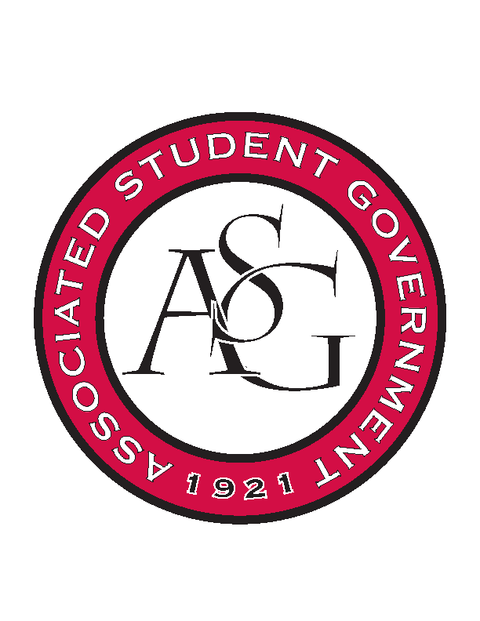
Associated Student Government

Office of Financial Affairs Meeting Agenda
September 6th, 2018

- Call to Order
- Roll Call
  - Adam Corral
  - Colin Gonzalez
  - Emily Richey
  - Kirsten James
  - Madeline Brown
  - Ploy Pleetissamuth
  - Sofia Hadley
  - William Neely
  - Zachary Keating
Proxies
  - Alexis Valdes
  - Brittany Fulmer
  - Nicholas Foster
  - Sally Gairhan
- Approval of the Minutes
- Appeals
  - None
- Audit Reports
  - None
- Old Business
- Geo-Institute Graduate Student Organization
- Iranian Students Association
- The Higher Education Organization – NODA Conference
- The Higher Education Organization – TACUSPA Conference
- Technology and Engineering Education Collegiate Association
- Tau Beta Pi
- Anthropology Graduate Student Consortium
- New Business
  - Space and Planetary Association for Collaboration and Education Hogs
  - Greek Life Budget Portal
  - Society of Hispanic Professional Engineers
  - Contemporary Sculpture Society
  - The Higher Education Organization
  - Society of Women Engineers
  - UARK Gaming
  - Crop, Soil, and Environmental Sciences Undergraduate Club
- Announcements
  - Cabinet events – Elizabeth
  - Send bios for website if you haven’t already
- Adjournment

