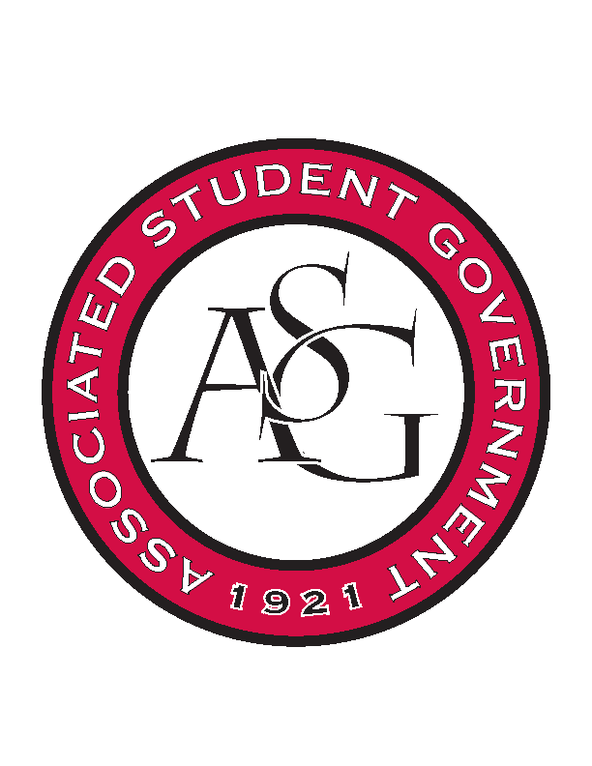
Associated Student Government

Office of Financial Affairs Meeting Minutes
October 11th, 2018

- Call To Order
- Roll Call
  - Adam Corral
  - Colin Gonzalez
      - Proxy--Alexis
  - Emily Richey
  - Kirsten James
  - Madeline Brown
      - Proxy--Brittany
  - Ploy Pleetissamuth
  - Sofia Hadley
      - Absent
  - William Neely
  - Zachary Keating
      - Proxy--Sally
Proxies
  - Alexis Valdes
  - Brittany Fulmer
  - Nicholas Foster
      - Absent
  - Sally Gairhan
- Approval of the Minutes
- Appeals
  - Saudi Students Club
      - Event 2 weeks from now?
      - Important to present culture and middle eastern culture because there is currently no direct connection between the students and the culture
      - Educating students on the culture
      - Want to correct misconceptions on culture—women
      - Divided into 3 sections
      - One: Arabian past history and present day
      - Two: Arabic words and letters and correcting ideas on Islam
      - Three: Women—correcting misconceptions, will be presenting Saudi women, roles women play in Saudi Arabia and history
      - Provided Chartwells with recipes because they believe the food will be educational
      - Questions
        - Would you be opened to changing the date?
          - Yes—gives us more time to be well prepared
        - Who will be helping with the event?
          - People from the club
        - What are the printed educational materials ($120)?
          - Handouts that will be colored (400-600)
          - Have you considered printing off these handouts in the RSO workspace? It is a free resource.
            - We will think about that
        - What is the process for the materials coming from the Embassy?
          - We will be paying for shipment. I think it does not take more that 5 days. They are coming from Washington D.C. $300 is the shipping fees.
        - Would you consider taking the event inside since it will be cold?
          - When we do it inside, we are not allowed to bring anything from outside like Arabian sweets, cooked in our way, the Union does not allow us to bring in outside food.
        - You cannot cook or prepare any food that is not made in an approved kitchen. It has to be certified.
          - Even if it is outside?
          - We have no control when it is not in an approved university kitchen.
          - We decided to cook at home because it will not be as good if we do not cook it. Chartwells will do a good job, but the cultural food will not be as good.
          - You can take your recipes to the chefs.
          - You could cook in the kitchens in Holcombe hall.
        - What is your plan in the event that it is raining or cold?
        - _____ from the Office of International Students can provide with more information.
        - Is the Union going to allow us to bring food in if it is raining outside?
          - No, you can only have Chartwells.
        - October 31st is the soonest you can host the event if you do everything immediately.
          - We are looking for a Tuesday or Thursday
          - We prefer November 1st
        - We will need the certified kitchen contact information
        - Would you consider relocating so that you can have your approved food inside?
          - Our main purpose is to attract more people in order to educate them
        - Reynolds Center Benefits
          - Restaurants cater to Saudi food
          - If we rent tents and buy food and it is rained out, we are out $100
        - What time is the event?
          - 9 a.m. – 5 p.m.
        - Maybe for the next event, plan in advanced and prepare the food in a certified kitchen
        - Can a chef approve the food?
          - No, it must be a certified location
        - We will look at the Verizon Ballroom
          - We are not sure if you will be able to get the reservation for the locations
        - Should we reserve the ball room and tables inside after we hear of the decision?
          - If the board approves the budget, you will need to reserve the room. If you cannot get the space, we will have to resend the funding.
          - If the board funds the decision, call tomorrow to reserve the space.
          - You can go to 519 and someone can check the database for the connections lounge or ballroom.
        - Neither the ballroom or the connections lounge are available – Neely
          - Next Tuesday, connections lounge is open from 9-noon
          - 20th whole ballroom is open as well as connections lounge
          - Week after thanksgiving break the connections lounge is open
          - https://virtualems.uark.edu
        - What is the time limit for the event?
          - No time limit
        - The connections lounge will be open to more students
        - We would like the 29th of November
      - Denied (0-8)
        - You will need to attend another pre-event meeting
        - You will be able to resubmit the budget
- Audit Reports
- Old Business
  - Alpha Kappa Delta
      - Approved (8-0)
  - The Higher Education Organization
      - Approved (8-0)
  - Russian-Eurasian Student Organization
      - Approved (8-0)
  - African Students Organization
      - Leave the $75 cleaning fee
      - Approved (8-0)
- New Business
  - Panamanian Student Organization
      - Stuff for the tables? Flowers? We cannot fund decorations. Are the flowers educational?
      - Motion to cut the boarder decorations--$27.50
        - Approved to cut (7-0)
      - We cannot fund the purchase of table cloths. You can rent them from Chartwells.
      - Motion to cut the table cloths – $125.00
        - Approved to cut (6-1)
      - New miscellaneous total--$345.00
      - What is the purpose of up lighting?
      - Approved (7-0)
  - Chi Alpha
      - We can only fund $1750
        - You can distribute this across the students attending in whatever way you want to
      - Can you provide more details about the conference?
      - What part of the conference fee are we paying for?
      - Approved (8-0)
  - oSTEM at University of Arkansas
      - Can you please clarify the registration date?
      - What will you bring back to share with the students here?
      - If there are awards they must come back to the RSO, not the individual.
      - Approved (8-0)
  - Students for a Free Tibet
      - How will you get students to attend your event?
      - Clarify the date and event itinerary
      - Who is speaking at the event?
      - Who are we flying in?
      - Approved (7-0)
  - International Students Organization
      - Approved (6-0)
  - Stand Up for Reproductive Rights and Gender Equity
      - Approved (6-0)
  - Vietnamese Student Association
      - We cannot fund non-perishable items, attire, woodblock printing, and you cannot prepare food in an unapproved kitchen
      - Late
      - Denied (0-7)
  - UARK Music Performers Producers & Professionals
      - Why two nights?
      - Can you itemize the sound equipment? We cannot buy, we can only rent the equipment
      - FPAC why is it full price when they are co-sponsors?
      - Who is the sound technician?
      - Approved (7-0)
  - Alpha Iota Rho
      - The location is not on the bus route or within walking distance, therefore we cannot provide funding
      - 254, 265, 253
      - They have 70 members and they are expecting 20 students
      - We do not see this as educational for the entire student body
      - Are you using the administrative fees for advertisement of your RSO?
      - Admin Fees Denied (0-7)
      - Denied (0-7)
  - Board of Advocates
      - Can you please provide an itemized list from Slims Chickens?
      - Where are the drinks coming from?
      - Please provide a quote from the caterer
      - Seems exclusive
      - Is this a regularly scheduled meeting? 283
      - Can any other student go watch?
      - Denied (0-7)
  - Biology Graduate Student Association
      - Can you provide an itemized list from Flying Burrito?
      - Are there any co-sponsors because you are not asking for travel expenses?
      - What is the intention behind feeding 40% of the attendees?
      - Approved (7-0)
  - Millicent Nkirote Gikunda
      - Are you involved in an RSO? Could you apply under that organization?
      - Join SOOIE!
      - Approved (7-0)
- Announcements
  - Hunger Talks—October 17th
  - Journalism in the Fake News Era—October 18th
  - Homecoming Parade—October 19th
  - Debate for the Senate Race—October 23rd
  - ASG All Call—October 23rd
  - Diversity Town Hall—October 24th
  - Hotdogs with Head Hogs—October 25th
  - Lighting Survey—October 30th
  - Make a Difference Day—November 3rd
- Adjournment

