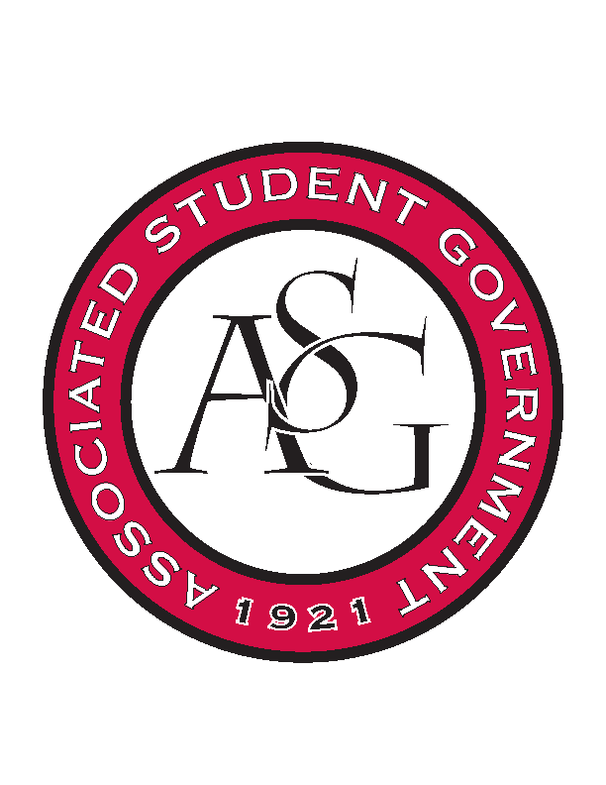
Associated Student Government

Office of Financial Affairs Meeting Minutes
October 17th, 2018

- Call To Order
- Roll Call
  - Adam Corral
  - Colin Gonzalez
  - Emily Richey
      - Nick
  - Kirsten James
      - Alexis
  - Madeline Brown
  - Ploy Pleetissamuth
  - Sofia Hadley
  - William Neely
      - Sally
  - Zachary Keating
Proxies
  - Alexis Valdes
  - Brittany Fulmer
      - Not here
  - Nicholas Foster
  - Sally Gairhan
- Approval of the Minutes
- Appeals
- Audit Reports
  - Nick Foster – Chinese Students and Scholars Association
  - Colin Gonzalez – Chinese Students and Scholars Association
  - Kirsten James – Razorback Booster Club
- Old Business
  - Panamanian Students Organization
      - Where will the uplighting be? Are you relying solely on the uplighting to light the performance?
      - What is the significance of the flowers?
      - Motion to cut flowers—minus $240
        - Approved to cut (8-0)
      - Approved (8-0)
  - Chi Alpha
      - Motion to decrease budget to $1600 ($50/30 students)
        - Approved to cut (9-0)
  - oSTEM at the University of Arkansas
      - Approved (9-0)
  - Students for a Free Tibet
      - Approved (9-0)
  - International Students Organization
      - Approved (9-0)
  - Stand Up for Reproductive Rights and Gender Equity
      - Approved (9-0)
  - UARK Music Performers Producers and Professionals
      - Motion to change the hotel rooms from one room for two days to two rooms from one night
        - Approved (9-0)
      - Motion to cut per diem to $46 (one day)
        - Approved (9-0)
      - Motion to cut the equipment
        - Motion denied (6-3)
      - Approved (9-0)
  - Biology Graduate Student Association
      - Approved (9-0)
  - Millicent Nkirote Gikunda – Individual Conference
      - Approved (9-0)
- New Business
  - Electrochemical Society - University of Arkansas student chapter
      - Can you buy your sodas from Walmart?
      - Approved (9-0)
  - Biology Club
      - Will you have an educational discussion before/after the movie?
      - Can you provide a quote for the film rights?
      - Approved (9-0)
  - Japanese Student Association
      - Where are the miscellaneous purchases coming from?
      - Approved (9-0)
  - Vietnamese Student Association
      - In what way is the painting culturally relevant? (brushes)
        - Could leftover brushes be potentially donated to the RSO office space
      - Motion to cut the “Dong Ho Painting”
        - Motion approved (9-0)
      - Lines 194 and 195
      - Approved (9-0)
  - Inspirational Chorale
      - Will the event be ticketed?
      - How will this event be educational?
      - How will you educate the audience on the music? Will you have an educational discussion?
      - Approved (9-0)
  - Graduate Society of Women Engineers at the University of Arkansas
      - Ineligible for funding because they have already requested during this round Line 33-40
      - Denied (0-9)
  - Black Law Students Association
      - Late for early bird
      - Denied (1-8)
  - Walton College Finance Association
      - Late
      - 2 liters?
      - Denied (0-9)
- Announcements
  - Do your audits!
  - Standing rules meeting next week
  - Journalism in the Fake News Era—October 18th
  - Homecoming Parade—October 19th
  - Debate for the Senate Race—October 23rd at 7:00
  - ASG All Call—October 23rd at 5:00
  - Diversity Town Hall—October 24th
  - Hotdogs with Head Hogs—October 25th
  - Lighting Survey—October 30th
  - Make a Difference Day—November 3rd
- Adjournment

