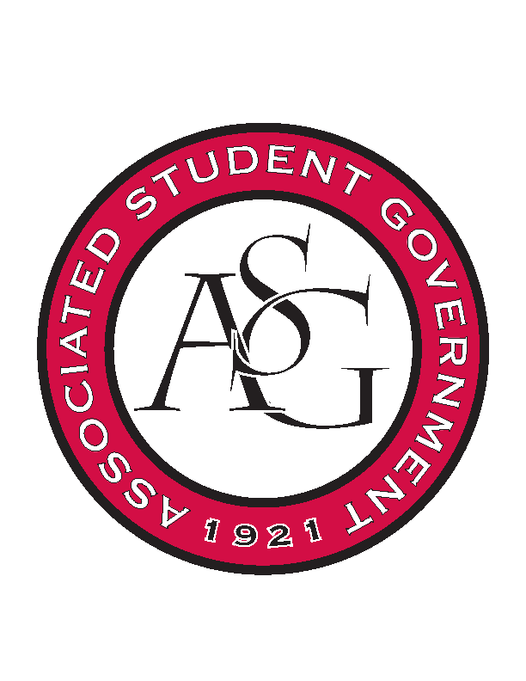
Associated Student Government

Office of Financial Affairs Meeting Minutes
October 4th, 2018

- Call To Order
- Roll Call
  - Adam Corral
  - Colin Gonzalez
  - Emily Richey
  - Kirsten James
  - Madeline Brown
  - Ploy Pleetissamuth
  - Sofia Hadley
      - Proxy—Brittany
  - William Neely
  - Zachary Keating
Proxies
  - Alexis Valdes
  - Brittany Fulmer
  - Nicholas Foster
  - Sally Gairhan
      - Absent
- Approval of the Minutes
- Appeals
- Audit Reports
- Old Business
  - SPACE Hogs
      - We will fund packaged food
      - Approved (9-0)
        - Nick Foster voted for Ploy
  - Graduate Society of Women Engineers at the University of Arkansas
      - We approved funding delivery
      - Approved (9-0)
  - Indian Cultural Association
      - $1935 before tax $2138.18 after tax for catering
      - Approved (9-0)
  - Il Circolo Italiano
      - Motion to cut the hotel and per diem to one night
        - Approved (9-0)
      - Approved (9-0)
  - Saudi Students Club
      - $3,721.95 for Chartwells catering
      - What will the $120 be used for?
      - Shipment of educational materials?
      - We would recommend hosting this event inside
      - Denied (0-9)

- New Business
  - Alpha Kappa Delta
      - Where is the speaker coming from?
      - Approved (9-0)
  - Chi Alpha
      - Late
      - Denied (0-9)
  - UARK Gaming
      - We cannot fund AV equipment like headphones
      - Denied (0-9)
  - The Higher Education Organization
      - We have other organizations on campus that host mock interviews. What makes your event different than the events that these organizations host?
      - Approved (8-1)
  - Russian-Eurasian Student Organization
      - Approved (9-0)
  - African Students Organization
      - Can you provide an itemized list from Chartwells?
      - Why is there a cleaning fee? Can you provide a quote from the Union?
      - Can you provide an itinerary?
      - Why is another stage necessary?
      - Approved (9-0)
- Announcements
  - First Round Standing Rules meeting proposal: October 25th
      - Continue to make notes to improve clarity of the Standing Rules
  - Audit events! Check Shani’s email! Events funded by OFA will have asterisks
  - Mrs. Jody would like us to comment on budgets on Hogsync portal!
  - National Readership Week—October 7th-13th
  - Hog out the Vote Initiative—October 8th
  - Crosswalk Safety Day—October 10th
  - Chancellors Ball—October 10th
  - Global Ethics Day, “Journalism in the Fake News Era”—October 18th
  - Community Celebration Week—October 22nd-26th
  - Lighting the Way—October 30th
  - Make a Difference Day—November 3rd
  - Scooter Safety Awareness Day—November 7th
- Adjournment

