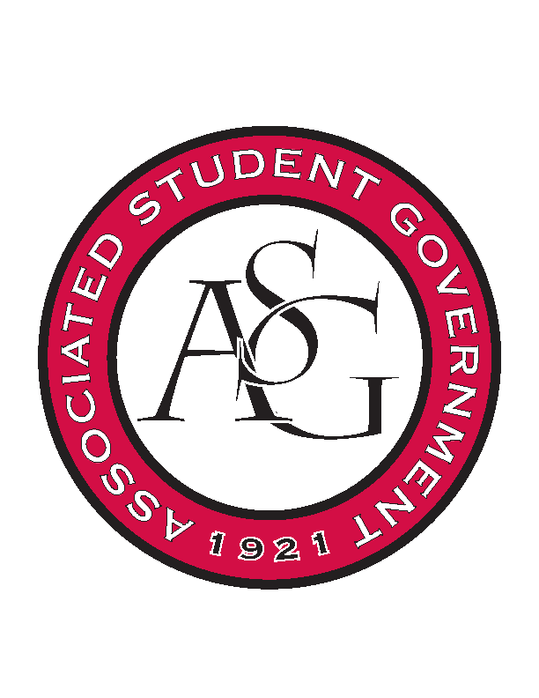
Associated Student Government

Office of Financial Affairs Meeting Minutes
November 15, 2018

- Call To Order
- Roll Call
  - Adam Corral
  - Colin Gonzalez
  - Emily Richey
  - Kirsten James
  - Madeline Brown
  - Ploy Pleetissamuth
      - Proxy: Alexis
  - Sofia Hadley
  - William Neely
  - Zachary Keating
Proxies
  - Alexis Valdes
  - Brittany Fulmer
  - Nicholas Foster
  - Sally Gairhan
- Approval of the Minutes
- Appeals
- Audit Reports
  - Russian Eurasian Student Organization: Nick Foster
- Old Business
  - Association of Ceramic Enthusiasts
      - Approved (9-0)
        - Sally proxy for Adam
        - Alexis proxy for Ploy
  - Horticulture Club
      - Approved (9-0)
        - Sally proxy for Adam
        - Alexis proxy for Ploy
- New Business
  - UARK Gaming
      - Late
      - Denied (0-9)
  - Association of Ceramic Enthusiasts
      - We do not fund RSVP events
      - We can only fund one night and one per diem
      - Motion to cut one night of hotel and one day of per diem
        - Motion passed (9-0)
      - Hotel and per diem cut to one night
      - Approved (9-0)
- FRIENDSGIVING
- Announcements
  - December 4th: End of Year Party
- Adjournment

