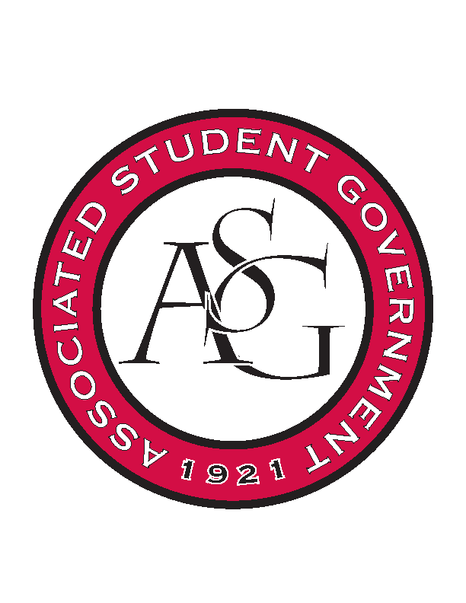
Associated Student Government

Office of Financial Affairs Meeting Minutes
November 29, 2018

- Call To Order
- Roll Call
  - Adam Corral
  - Colin Gonzalez
  - Emily Richey
      - Alexis
  - Kirsten James
      - Sally
  - Madeline Brown
  - Ploy Pleetissamuth
  - Sofia Hadley
  - William Neely
  - Zachary Keating
Proxies
  - Alexis Valdes
  - Brittany Fulmer
      - Absent
  - Nicholas Foster
      - Absent
  - Sally Gairhan
- Approval of the Minutes
- Appeals
- Audit Reports
  - Sally Gairhan - Inspirational Chorale, Power and Privilege
  - Brittany Fulmer – Japanese Students Association
  - Colin Gonzalez – Students for a Free Tibet, Friends of India
  - Madeline Brown – Panamanian Student Organization, Power and Privilege
  - Sofia Hadley – Panamanian Student Organization
- Old Business
    - Association of Ceramic Enthusiasts
      - Cut per diem and hotel for one night
      - Approved (9-0)
- New Business
  - Chinese Students and Scholars Association
      - Is the special set up decorations?
      - Can you provide an itinerary for the event? What will be going on during the event?
      - What will the cultural games consist of?
      - Approved 7-2
  - Alpha Epsilon Delta
      - New total: 2024.51 (remove fees)
      - How do you plan to get 140 students to attend the event?
      - Approved (9-0)
  - Black Law Students Association
      - Late
      - Denied (9-0)
  - Chi Sigma Alpha
      - Mrs. Jodie will get them in with the early rate
      - Approved (9-0)
- Announcements
  - ASG End of Year Party—December 4th 7:30
  - Application for a Proxy is coming out soon!
  - Gift exchange next Thursday?
- Adjournment

