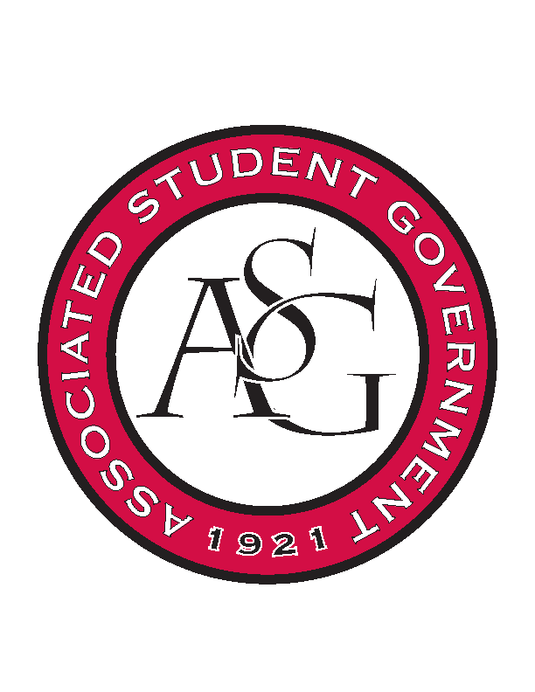
Associated Student Government

Office of Financial Affairs Meeting Minutes
November 8, 2018

- Call To Order
- Roll Call
  - Adam Corral
      - Nick
  - Colin Gonzalez
  - Emily Richey
  - Kirsten James
  - Madeline Brown
  - Ploy Pleetissamuth
      - Brittany for first 10 minutes
  - Sofia Hadley
  - William Neely
  - Zachary Keating
Proxies
  - Alexis Valdes
      - Absent
  - Brittany Fulmer
  - Nicholas Foster
  - Sally Gairhan
      - Late
- Approval of the Minutes
- Appeals
- Audit Reports
  - William Neely & Izzy Garcia—Space Hogs
- Old Business
  - Christian Graduate Student Fellowship
      - Motion to add $50 to the honorarium
        - Motion passed (9-0)
        - Honorarium bumped to $350
      - Approved (9-0)
  - American Society of Civil Engineers
      - Approved (9-0)
  - CRU
      - Approved (9-0)
- New Business
  - Association of Ceramic Enthusiasts
      - Cut to $1,750 (line 216)
      - Approved (9-0)
  - STORE
      - Late
      - Denied (0-9)
  - National Association for Music Education
      - Late
      - Denied (0-9)
  - Horticulture Club
      - Approved (9-0)
- Announcements
  - Veterans Day: Tomorrow at 2 at the Reynolds Center
  - November 14th: Lighting the Way and Leadership Summit
  - December 4th: End of the Semester Party
- Adjournment

