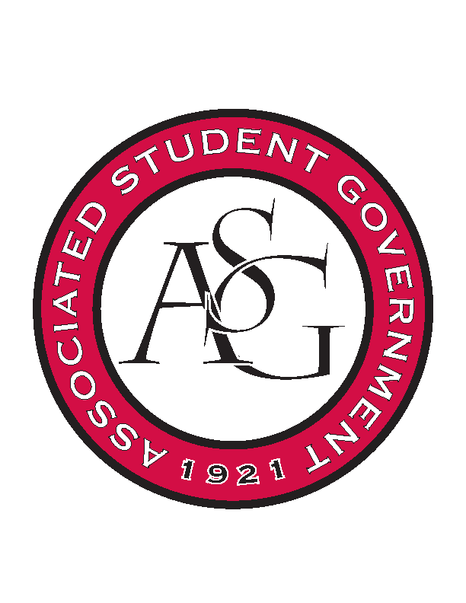
Associated Student Government

Office of Financial Affairs Meeting Minutes
September 13th, 2018

- Call to Order
- Roll Call
  - Adam Corral
  - Colin Gonzalez
  - Emily Richey
  - Kirsten James
  - Madeline Brown
  - Ploy Pleetissamuth
  - Sofia Hadley
  - William Neely
  - Zachary Keating
      - Sally proxy first 3 minutes
Proxies
  - Alexis Valdes
  - Brittany Fulmer
  - Nicholas Foster
  - Sally Gairhan
- Approval of the Minutes
- Appeals
  - None
- Audit Reports
  - None
- Old Business
  - Greek Life Budget Portal
      - Cut them to 18 students and 1 advisor
      - $680.00
      - Approved (9-0)
  - Society of Hispanic Professional Engineers
      - We will allocate $1750.00
      - Approved (9-0)
  - Crop, Soil, and Environmental Sciences Undergraduate Club
      - Approved (9-0)
  - The Higher Education Organization
      - Approved (9-0)
  - Society of Women Engineers
      - Approved (9-0)
- New Business
  - Iranian Students Association
      - Pulled out because they added food
      - Pre-event consultation
      - Submitted new budget, we will read it next week
      - Same budget + food
  - Graduate Society of Women Engineers at the University of Arkansas
      - Approved (9-0)
  - Caribbean Student Association
      - How will they specifically make this educational? Great idea, we just need more details!
      - Approved (9-0)
  - Food Science Club
      - Apples for $500?
        - Is there a specific reason you are buying apples from this place?
        - Why do you need so many apples?
      - Labels were very expensive too
      - What time will you host this event?
      - Approved (7-2)
  - Contemporary Sculpture Society
      - Approved (9-0)
  - Biomedical Engineering Society
      - Late
      - They can resubmit by Saturday
      - Denied (9-0)
  - Student Alumni Association
      - What is the rate for the UAPD officers?
      - Approved (8-0-1)
- Announcements
  - Start doing audits!
  - ASG Retreat is this Sunday 1-5
      - Eat lunch before you come but there will be snacks
      - Business casual
      - Grad Ed Auditorium
  - Soccer game on September 20th against Texas A&M
  - October 1st-5th is ring week
  - Prescribed to Death Memorial is October 3rd-9th
      - Educating students on the dangers of the Opioid Epidemic
  - National Readership week October 7th-13th
  - Audrey Walker needs help with Boss Hog Outfitter
      - Apply on Hogsync—closes next Friday!
  - Sign up for Rolling with the Razorbacks because we got a second bus!
      - September 22nd
- Adjournment

