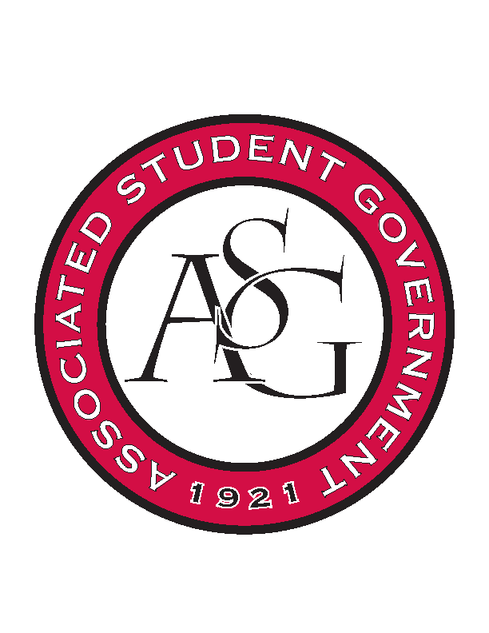
Associated Student Government

Office of Financial Affairs Meeting Minutes
September 20th, 2018

- Call To Order
- Roll Call
  - Adam Corral
  - Colin Gonzalez
  - Emily Richey
  - Kirsten James
  - Madeline Brown
  - Ploy Pleetissamuth
  - Sofia Hadley
  - William Neely
  - Zachary Keating
      - Alexis proxy (first 5 minutes)
Proxies
  - Alexis Valdes
  - Brittany Fulmer
  - Nicholas Foster
  - Sally Gairhan
- Approval of the Minutes
- Appeals
- Audit Reports
- Old Business
  - Graduate Society of Women Engineers at the University of Arkansas
      - Approved (9-0)
  - Caribbean Student Association
      - They provided explanation on the educational value
        - Dance, art, music, and cuisine
        - Students can participate in carnival
      - Approved (9-0)
  - Food Science Club
      - Approximating to buy 1000 lbs of apples
        - Final volume will be less due to production
        - We are paying for unusable apples
      - A club member is interning at A&A
        - Could apples be purchased elsewhere?
      - Why do they need labels on the jar?
      - Requests to tweak budget
        - Cut numbers of apples purchased to $15/person (25 people attending) = $375
          - Approved (8-1)
        - Cut number of labels to $195
          - Approved (8-1)
        - Approved total = $710
      - Approved (8-1)
  - Contemporary Sculpture Society
      - They did not turn in their event evaluation form for their last event
        - They have to turn this in
      - Approved (9-0)
  - Student Alumni Association
      - Approved (9-0)
- New Business
  - National Society of Black Engineers
      - Approved (9-0)
  - Iranian Students Association
      - Tickets required
      - Change travel airfare to $306.60
      - Please provide an itemized list of snacks
      - Approved (9-0)
  - The Higher Education Organization – Molly Kinder
      - Approved (9-0)
  - The Higher Education Organization - Carly Waschka
      - Approved (9-0)
  - International Bolivian Organization
      - Plastic or paper plates rather than Styrofoam
      - 250 plates requested and 30 people attending. Can you buy a smaller package of plates?
      - Approved (9-0)
  - The Higher Education Organization – Lauren Hughes
      - Approved (9-0)
  - The Higher Education Organization – Angelique Price
      - Approved (9-0)
  - InterVarsity Christian Fellowship
      - Cutting budget down to $1750 (per Standing Rules)
      - Approved (9-0)
  - Lambda Alpha Epsilon
      - Approved (9-0)
  - Federalist Society
      - Please provide a quote from Chick Fil A
      - Approved (9-0)
  - ALPFA
      - They will buy Cokes from Walmart
      - Add a line item for pizza from Eureka Pizza with price
      - We do not pay for delivery and tips
      - Itemized list for plates, cups, and cookies
      - Approved (9-0)
  - oSTEM at University of Arkansas
      - Social event? Soft skills learning experience?
      - Please provide itemized Chartwells budget
      - Denied (9-0)
  - Alpha Chi Sigma
      - Can they apply for Bookstore funding?
        - Markers and post it notes
        - Would they be using the markers and post it notes?
      - They can checkout trashcans for free from Office of Sustainability
      - Approved (9-0)
  - Friends of India
      - Do you need 750 bottles of water for 350 predicted attendees?
      - Do you need 3000 napkins?
      - We are not allowed to fund decorations
        - They can rent lights and lanterns from InTents
      - Only 15 non-students can be included in the food
      - Tickets for non-students
      - Approved (9-0)
        - Sally proxying for Sofia
  - Bangladesh Student Organization
      - What specifically will the students learn?
      - Could you provide an agenda?
      - Do you want tickets for crowd control?
      - Can you provide an itemized list of plates and utensils?
      - 185 people attending but only 56 active members. How do you plan on reaching 185 students?
      - Approved (9-0)
- Announcements
  - Soccer game tonight at 6 against Texas A & M
  - Ring Week is October 1st-5th
  - Prescribed to Death Memorial is October 3rd-9th
      - Educating Students on the dangers of the Opioid Epidemic
  - National Readership Week is October 7th-13th
  - Boss Hog Outfitter application closes tomorrow at noon!
- Adjournment

