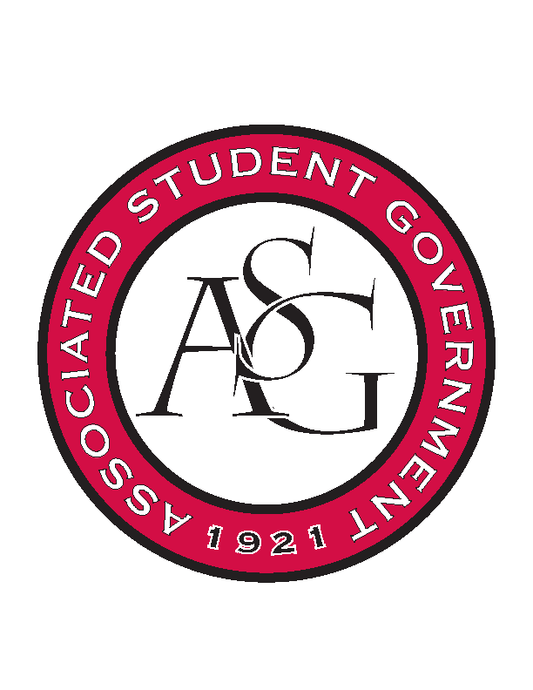
Associated Student Government

Office of Financial Affairs Meeting Minutes
September 27, 2018

- Call To Order
- Roll Call
  - Adam Corral
  - Colin Gonzalez
  - Emily Richey
  - Kirsten James
  - Madeline Brown
  - Ploy Pleetissamuth
      - Brittany proxy
  - Sofia Hadley
  - William Neely
  - Zachary Keating
Proxies
  - Alexis Valdes

  - Brittany Fulmer
  - Nicholas Foster
  - Sally Gairhan
- Approval of the Minutes
- Appeals
- Audit Reports
- Old Business
  - National Society of Black Engineers
      - Approved (9-0)
  - Iranian Students Association
      - Tickets required
      - Did not provide itemized list of snacks
      - Travel airfare was changed to $306.60
      - Approved (5-4)
  - The Higher Education Organization – Molly Kinder
      - Approved (9-0)
  - The Higher Education Organization – Carly Waschka
      - Approved (9-0)
  - International Bolivian Organization
      - Approved (9-0)
  - The Higher Education Organization – Lauren Hughes
      - Approved (9-0)
  - The Higher Education Organization – Angelique Price
      - Approved (9-0)
  - InterVarsity Christian Fellowship
      - Cut down to $1750
      - Approved (9-0)
  - Lambda Alpha Epsilon
      - Approved (9-0)
  - Federalist Society
      - Approved (8-1)
  - ALPFA
      - $5.36/pizza
      - They will be purchasing Cokes from Walmart
      - Approved (9-0)
  - Alpha Chi Sigma
      - Mrs. Jodie will look into cheaper office supplies at Staples for Post It Notes
      - Approved (6-3)
  - Friends of India
      - Motion to cut water bottle line to $40
        - Approved (9-0)
      - Approved (9-0)
  - Bangladesh Student Organization
      - What is a burner?
      - You cannot limit the number of student attendees
      - Approved (9-0)
- New Business
  - SPACE Hogs
      - The event is hosted in the Union, so you must use Chartwells as your caterer or you can bring up to $100 of packaged food
      - Approved (9-0)
  - UA Swing Kids
      - Can you apply for group discounts for the conference?
      - One day late
      - Denied (0-9)
  - Graduate Society of Women Engineers at the University of Arkansas
      - We cannot pay for a rental car
      - We cannot pay the cost of delivery
      - Approved (9-0)
  - Biomedical Engineering Society
      - Late
      - Denied (0-9)
  - oSTEM at University of Arkansas
      - Can you provide an itemized list from Chartwells? Drinks?
      - We cannot buy the carving kit
      - What are you doing besides carving pumpkins?
      - What makes this event educational?
      - How does this event fit the mission of your RSO?
      - Please itemize the $4 venue fee
      - How many pumpkins are you planning to purchase and where do you plan to purchase them from?
      - What activities will be going on during the event?
      - Denied (0-9)
  - Indian Cultural Association
      - Recruitment?
      - The budget needs to be listed as $9 x 150 + tax
      - Please provide an itemized list for the water bottles, plates, napkins
      - Where are you getting all of the miscellaneous purchases?
      - How is the event educational?
      - How is the DJ and dance tied into the event?
      - How are you planning to get students to go to the Alumni House?
      - Can you provide an email for the DJ, so we may request the appearance agreement?
      - Can you provide a confirmation from the Alumni House?
      - Who is Herman?
      - Approved (5-4)
  - Alpha Kappa Delta
      - Late
      - Denied (0-9)
  - Il Circolo Italiano
      - Does the speaker need 2 nights in the hotel? Is the speaker only meeting with students in the RSO on the second day?
      - Do you have a co-sponsor?
      - Approved (9-0)
  - Saudi Students Club
      - We cannot pay for delivery of food
      - If you are bringing in artifacts, we would recommend hosting the event inside.
      - “We misspoke, we are approving this by exception”
      - How is your event educational?
      - Can you provide an itemized list of the food, shipment of education materials, miscellaneous purchases, printed educational materials, and hyena dye and stencils?
      - Can you provide an invoice for the tents?
      - Will you be inviting professors and faculty?
      - Who will be working the event?
      - How will you get students to come to your event?
      - Approved (6-3)
Announcements
  - Next week!
      - Prescribed to Death Memorial
      - Ring Week
      - It’s on Us Week
      - DLC Laverne Cox—Wednesday at 7 p.m.
  - National Readership Week—October 7th-13th
  - Crosswalk Safety Day—October 10th
  - Chancellors Ball—October 10th
  - Global Ethics Day, “Journalism in the Fake News Era”—October 18th
  - Community Celebration Week—October 22nd-26th
  - Lighting the Way—October 30th
  - Make a Difference Day—November 3rd
  - Scooter Safety Awareness Day—November 7th
- Adjournment

