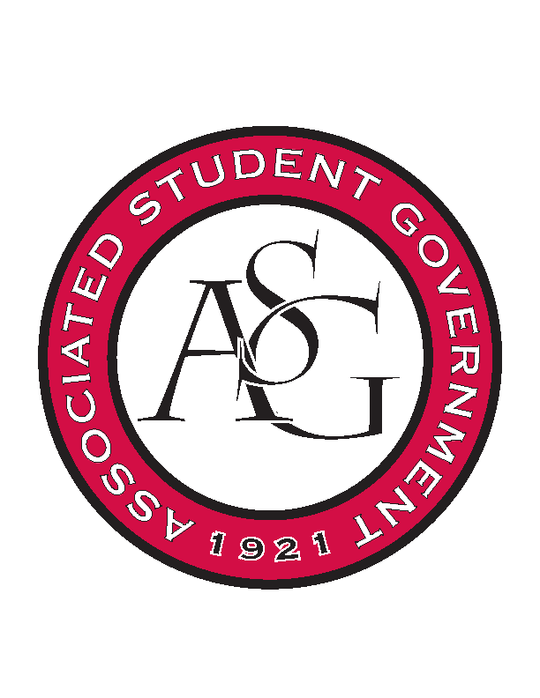
Associated Student Government

Office of Financial Affairs Meeting Minutes
December 6th, 2018

- Call To Order
- Roll Call
  - Adam Corral
  - Colin Gonzalez
  - Emily Richey
      - Proxy—Sally
  - Kirsten James
  - Madeline Brown
  - Ploy Pleetissamuth
  - Sofia Hadley
  - William Neely
  - Zachary Keating
Proxies
  - Alexis Valdes
  - Brittany Fulmer
      - Absent
  - Nicholas Foster
  - Sally Gairhan
- Approval of the Minutes
- Appeals
- Audit Reports
  - Adam - SURGE
  - Nick – Vietnamese Students Association
  - Alexis – African Students Association, Vietnamese Students Association, International Bolivian Organization
  - William – Fulbright Scholars, Vietnamese Students Association
  - Kirsten – Caffeinated Club
- Old Business
  - Chinese Students and Scholars Association
      - No cultural games
      - New total: $4901.63
      - Are the lights going to be used to up light something?
      - Motion to cut up lights to 5
        - Approved (7-2)
      - Approved (9-0)
  - Alpha Epsilon Delta
      - Approved (9-0
  - Chi Sigma Alpha
      - Approved (9-0)
- New Business
  - Hogs End Alz
      - Approved (9-0)
  - Alpha Kappa Psi
      - Approved (9-0)
  - Campus Y
      - Approved (9-0)
  - Printmaking Club
      - Late
      - Denied (0-9)
  - Graduate Students in English
      - Will there be a 2:1 student ratio?
      - Will this event be exclusive?
      - Can you provide an itemized list of the miscellaneous purchases?
      - Students from other universities must have a ticket.
      - In the event of left over boxed meals, do you plan to take these to Razorback Food Recovery?
      - Will there be a co-sponsor?
      - Last year the budget they submitted estimated 70 students and there were 40 students in attendance.
      - Based on last year’s attendance, how will you increase this year?
      - How many gallons of tea are you wanting to purchase?
      - Will you promote this event ono social media?
      - Can you provide the Chartwells PDF quote?
      - Approved (9-0)
- Announcements
  - Sophia will be graduating! :(
  - Audit reports are due Sunday by midnight
  - Proxy applications are live on HogSync
  - Coffee and Cookies Sunday @ 8:00 pm
- White Elephant Gift Exchange
- Adjournment

