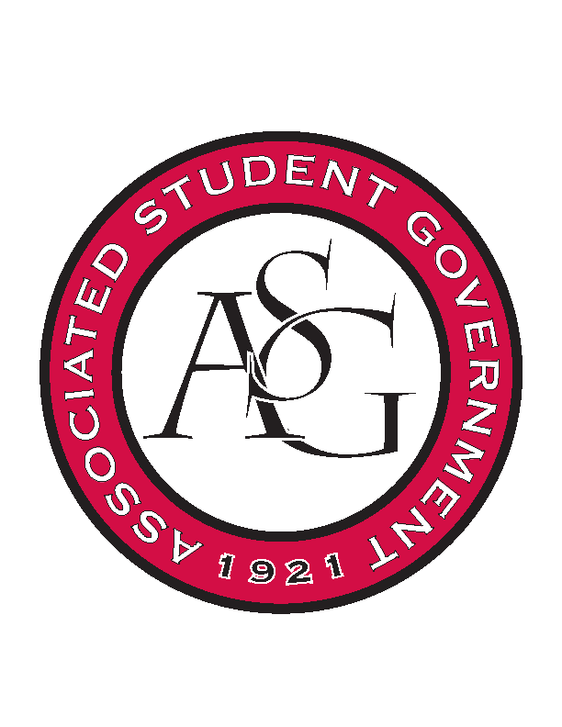
Associated Student Government

Office of Financial Affairs Meeting Agenda
January 24, 2019

- Call To Order
- Roll Call
  - Adam Corral
  - Alexis Valdes
  - Colin Gonzalez
  - Emily Richey
  - Kirsten James
  - Madeline Brown
  - Ploy Pleetissamuth
  - William Neely
  - Zachary Keating
Proxies
  - Brittany Fulmer
  - Nicholas Foster
  - Sally Gairhan
- Approval of the Minutes
- Appeals
- Audit Reports
- Tabled Budget – Graduate Students in English
- Old Business
  - American Society of Interior Designers
  - UA Photographic Society
  - First Baptist Church Fayetteville Collegiate Group
- New Business
  - Muslim Students Association
  - Vietnamese Students Association
  - African Students Association
  - Grace Chinese Christian Campus Fellowship
  - Zeta Phi Beta Sorority, Inc.
  - Printmaking Club
  - Minorities in Agriculture
  - Psychology Club
  - Board of Advocates
  - American Society of Civil Engineers
- Announcements
- Adjournment

