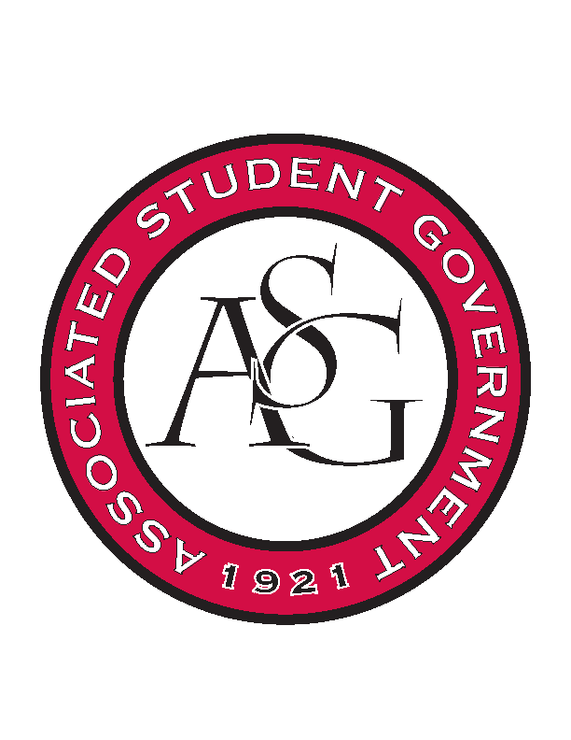
Associated Student Government

Office of Financial Affairs Meeting Minutes
February 21st, 2019

- Call To Order
- Roll Call
  - Adam Corral
  - Alexis Valdes
  - Colin Gonzalez
  - Emily Richey
  - Kirsten James
  - Madeline Brown
  - Ploy Pleetissamuth
      - Sally
  - William Neely
  - Zachary Keating
Proxies
  - Brittany Fulmer
  - Jissel Esparza
      - Absent
  - Kevin Smith
      - Proxy for Colin on Old Business
  - Nicholas Foster
  - Sally Gairhan
- Approval of the Minutes
- Appeals
  - Korean Food Cooking Club
      - Has the speaker done this kind of presentation before?
        - Yes, but not in the US. He is excited to come to Arkansas. He has contacted his company and sacrificed a lot of his vacation time to be here.
      - Did the ICT Band volunteer to participate or did you ask them?
        - They volunteered
      - Will the topic be about etiquette?
        - Yes, everyone will have the same topic. Everyone will share the same topic. Some people never have the opportunity to speak to everyone.
      - Do they have access to the Faulkner Center room the day before?
      - Are the other speakers practicing with him? Fashion show?
      - How do we feel about the two nights of the hotel?
        - He is flying into LA for a business trip, not directly here
      - Potentially cut to $12 per person
        - Cut one of the items
      - Motion to cut the waters
        - Approved (9-0)
      - Approved (9-0)
  - Arkansas Chemical Engineering Graduate Students
- Old Business
  - Friends of India
      - Approved (9-0)
  - Biology Graduate Student Association (1)
      - Approved (9-0)
  - Biology Graduate Student Association (2)
      - Approved (9-0)
  - Biology Graduate Student Association (3)
      - Approved (9-0)
  - American Institute of Chemical Engineers
      - Approved (9-0)
  - Kappa Alpha Psi Fraternity, Inc.
      - Approved (9-0)
  - Pi Kappa Alpha
      - Approved (9-0)
  - Diversity, Inclusion, and You Association
      - Appealed decision to cut the number of pamphlets to 130
      - Motion to vote on the pamphlets
        - Denied (0-9)
      - Approved (9-0)
- New Business
  - Russian-Eurasian Student Organization
      - Is the hotel $124 per night?
      - On the document on the reservation of the room, it says “tentative” for date
        - Is the room confirmed?
      - Approved (9-0)
  - National Residence Hall Honorary – NRHH
      - Approved (9-0)
  - Phi Beta Sigma Fraternity, Inc.
      - Line 260 of the Standing Rules
      - Denied (0-9)
  - Arkansas Chemical Engineering Graduate Students
  - Phi Beta Sigma Fraternity, Inc.
      - Can you provide an itinerary for the conference?
      - Is there potential for a monetary award at this conference? If so, you will need to put it in the RSO bank account, it cannot go to an individual.
      - Approved (9-0)
  - Stand Up for Reproductive Rights and Gender Equity
      - Late
        - Because of Spring Break
      - Denied (0-9)
  - Biology Graduate Student Association (1)
      - Approved (9-0)
  - Biology Graduate Student Association (2)
      - Approved (9-0)
  - Biological Engineering Student Club
      - Will be read next week
- Announcements
  - Do your audits!
  - ASG Debates next week Tuesday, Wednesday, Thursday
  - Voting starts March 4
  - Save AR Students week March 11-17
  - U of A Birthday April 3
- Adjournment

