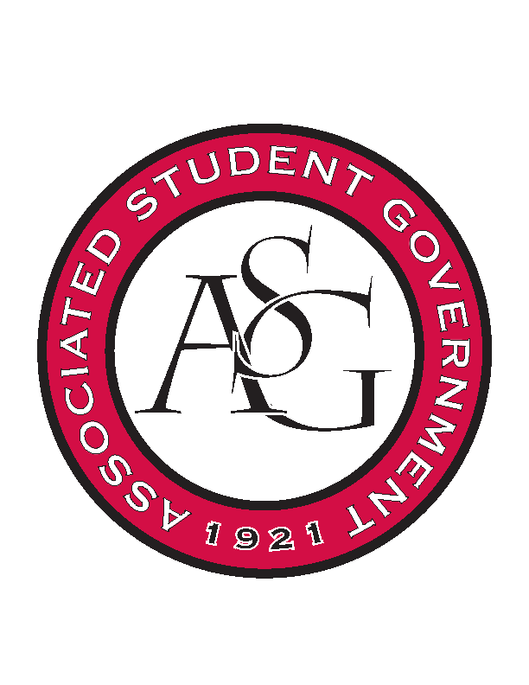
Associated Student Government

Office of Financial Affairs Meeting Minutes
February 7th, 2019

- Call To Order
- Roll Call
  - Adam Corral
      - Kirsten proxy
  - Alexis Valdes
  - Colin Gonzalez
  - Emily Richey
      - Nick proxy
  - Kirsten James
  - Madeline Brown
      - Absent
  - Ploy Pleetissamuth
      - Absent
  - William Neely
      - Sally proxy
  - Zachary Keating
Proxies
  - Brittany Fulmer
      - Absent
  - Jissel Esparza
      - Absent
  - Kevin Smith
      - Absent
  - Nicholas Foster
  - Sally Gairhan
- Approval of the Minutes
- Appeals
  - Muslim Students Association
- Tabled Budgets
- Old Business
  - African Students Association
      - Approved (7-0)
  - Muslima of UARK
      - Approved (7-0)
  - Arkansas Laserbacks
      - $20 for water and sodas
        - 9 2-Liters at $1.50
      - Approved (7-0)
      - Kirsten will audit!
  - Panamanian Students Organization
      - Approved (6-0-1)
  - American Society of Civil Engineers
      - Approved (7-0)
  - Student Nurses Association
      - Approved (7-0)
- New Business
  - Space and Planetary Association for Collaboration and Education Hogs
      - Late
      - Can reapply under on-site registration
      - Denied (0-7)
  - Diversity, Inclusion, and You Association
      - Re-submit with tickets?
      - How many programs are you printing?
      - Who is doing the printing of the programs?
      - Can you provide an itemized list for the miscellaneous items?
      - How will you promote the event?
      - Please resubmit!
      - Denied (0-7)
  - Geo-Institute Graduate Student Organization
      - The maximum paid will be $250 per person
      - Approved (7-0)
  - Kappa Kappa Psi
      - Motion to table
        - Approved (7-0)
  - First Baptist Church Fayetteville Collegiate Group
      - Do you want this taken out of this year or the fall budget?
      - Approved (7-0)
  - Biology Graduate Student Association
      - Approved (7-0)
- Announcements
- Adjournment

