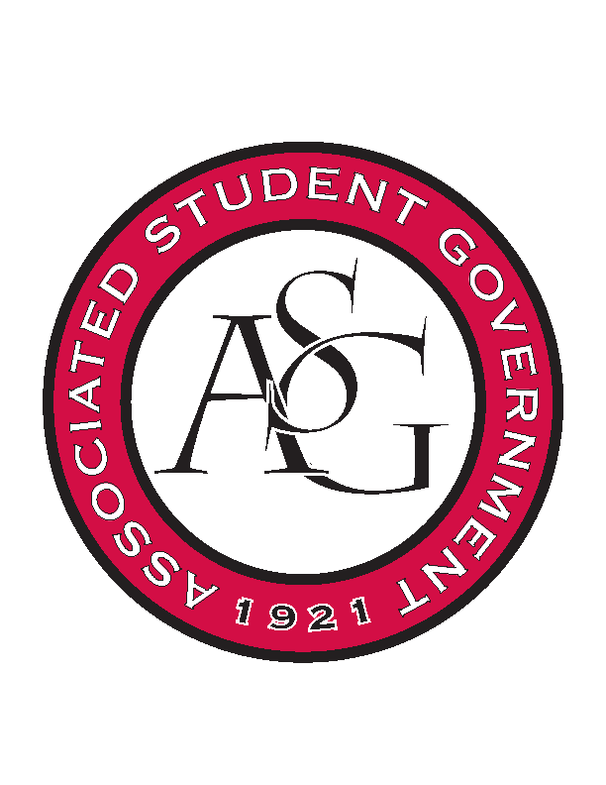
Associated Student Government

Office of Financial Affairs Meeting Minutes
February 28th, 2019

- Call To Order
- Roll Call
  - Adam Corral
      - Sally proxy
  - Alexis Valdes
  - Colin Gonzalez
  - Emily Richey
  - Kirsten James
      - Brittany proxy
  - Madeline Brown
  - Ploy Pleetissamuth
  - William Neely
  - Zachary Keating
      - Nick proxy
Proxies
  - Brittany Fulmer
  - Jissel Esparza
      - Absent
  - Kevin Smith
  - Nicholas Foster
  - Sally Gairhan
- Approval of the Minutes
- Old Business
  - Russian-Eurasian Student Organization
      - Approved (8-0)
  - National Residence Hall Honorary – NRHH
      - Approved (8-0)
  - Phi Beta Sigma Fraternity, Inc.
      - Approved (8-0)
  - Biology Graduate Student Association (1)
      - Approved (8-0)
  - Biology Graduate Student Association (2)
      - Approved (8-0)
- New Business
  - Biomedical Engineering Society
      - Late
      - Denied (0-8)
  - Space and Planetary Association for Collaboration and Education Hogs
      - What movie will be showed?
      - Can you provide a quote for the movie rights, room reservation, and the pizza and drinks?
      - Approved (6-2)
  - oSTEM at University of Arkansas
      - This is a networking event so it will need to be capped at $500
      - Please provide a quote
      - Who are the business professionals attending?
      - If they are speaking, we will need an email address and names.
      - Please be careful with wording because the description of the event sounds exclusive
      - Late
      - Please resubmit!
      - Denied (0-9)
  - Biological Engineering Student Club
      - No supplemental documentation submitted
        - Please provide supplemental documentation
      - Approved (9-0)
  - American Institute of Architecture Students
      - Late
      - Look for on-site registration!
      - Denied (0-9)
  - Property Law Society
      - Is this a regular meeting?
      - Reapply – line 13, other students would find it fun
      - Please provide a quote next time
      - Late by a day!
      - Denied (0-9)
  - Brazilian Student Organization
      - Approved (9-0)
  - International Students Organization
      - Outside of mandatory advertisement, how will you promote the event?
      - Please begin advertising at least 2 weeks before!
      - Approved (9-0)
  - Alpha Kappa Psi
      - They only have $260 left for conferences
        - They received funding in January
      - Motion to cut the budget to $260
        - Approved (9-0)
      - Approved (9-0)
  - Japanese Student Association
      - We cannot fund decoration and games
      - Will the food be prepared in an approved kitchen?
      - Can you itemize the food items?
      - Can you provide supplemental documentation?
      - We cannot fund prizes (the candy)
      - Motion to cut décor and games (line 2)
        - Approved (9-0)
      - What do you mean by “decoration for advertising”?
      - You can apply for $100 of printed educational materials
      - Line 14 ticket selling?
      - We need more details about the events
      - Food cannot be brought into the Reynolds Center, it can only be held outside of the area
      - Standing rules: look at what funding round RSOs should apply for
      - Denied (0-9)
  - Delta Delta Delta
      - Approved (9-0)
  - Minorities in Agriculture, Natural Resources, and Related Sciences (5 Individual Conferences)
      - Late
      - Students did not find out that they were selected for presentation the presentation until 2 days after their budget should have been submitted
      - Standing Rules should clearly state where individuals should apply for funding (group vs individual conference)
      - What will be awarded at the awards banquet?
      - We cannot fund conferences where alcohol is included in the registration fee – happy hour
      - Denied (0-9)
        - Late
  - National Residence Hall Honorary – NRHH
      - Will there be alcohol at the Mardi Gras mascaraed?
      - Approved (9-0)
  - IEEE Women in Engineering Student Branch Affinity Group at the University of Arkansas
      - Colin and Neely are auditing
      - Approved (9-0)
  - Printmaking Club
      - Will this event be open to all students?
        - Classroom events
      - Why does the artist need two nights?
      - Why does the artist need a tour of the museums?
      - 2 day per diem and 2 day hotel?
      - Approved (8-1)
- Announcements
  - Do your audits
  - ASG Townhall tonight!
  - Voting starts March 4
  - Save AR Students week March 11-17
  - U of A Birthday April 3
- Adjournment

