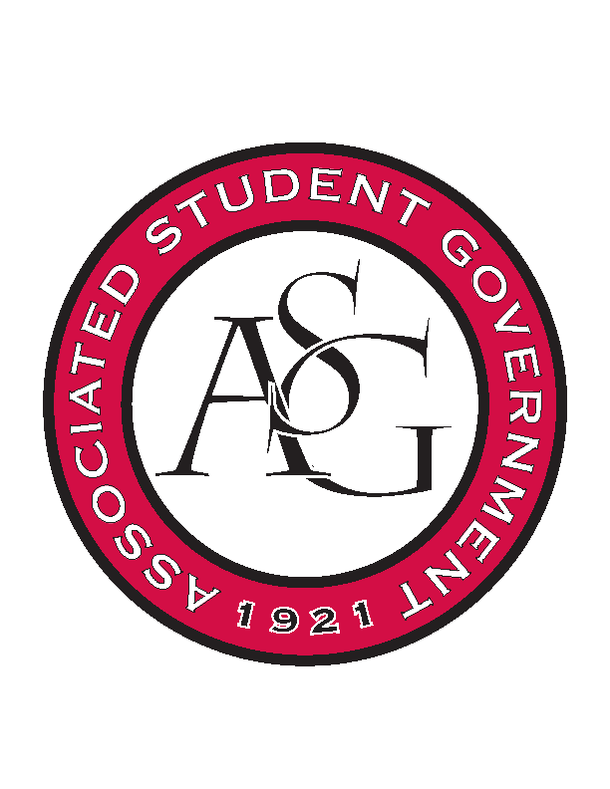
Associated Student Government

Office of Financial Affairs Meeting Minutes
March 7th, 2019

- Call To Order
- Roll Call
  - Adam Corral
  - Alexis Valdes
  - Colin Gonzalez
      - Sally
  - Emily Richey
  - Kirsten James
  - Madeline Brown
  - Ploy Pleetissamuth
  - William Neely
  - Zachary Keating
Proxies
  - Brittany Fulmer
  - Jissel Esparza
      - Absent
  - Kevin Smith
  - Nicholas Foster
  - Sally Gairhan
- Approval of the Minutes
- Old Business
  - Printmaking Club
      - Motion to cut the per diem and hotel to one night (line 2 & 3)
        - Approved (9-0)
      - Approved (9-0)
  - Space and Planetary Association for Collaboration and Education Hogs
      - Approved (7-2)
  - Biological Engineering Student Club
      - Can you provide the contact information or an email thread?
      - Motion to table
        - Approved (8-1)
  - Brazilian Student Organization
      - Approved (9-0)
  - International Students Organization
      - Approved (9-0)
  - Alpha Kappa Psi
      - Approved (9-0)
  - IEEE Women in Engineering Student Branch Affinity Group at the University of Arkansas
      - Approved (9-0)
  - Delta Delta Delta
      - Approved (9-0)
  - National Residence Hall Honorary – NRHH
      - Approved (9-0)
- New Business
  - Gamma Eta Sorority, Inc.
      - The colored pencils and paint brushes will need to go to the RSO work space after the event
      - What will be happening to the canvases?
      - How will the activities be educational?
      - The colored pencils do not fall under honorarium
      - Please provide supplementary documentation for Ozark Catering
      - You will not be able to bring animals to the event
      - How is the photo booth educational?
      - How will the activities represent the people chosen?
      - Denied (4-5)
  - Tau Beta Pi
      - The posters should be placed all over campus
      - Please reach out to all parts of campus!
      - Approved (9-0)
  - Biology Graduate Student Association
      - Late
      - Cannot fund alcohol
      - Denied (0-9)
  - Filipino Students Organization
      - Is this a recruitment event?
      - Recruitment event is capped at $150
      - Will the desserts be made in an approved kitchen?
      - Can you provide supplemental documentation for what you are purchasing?
      - Motion to cut the budget to $150
        - Approved (9-0)
      - Approved (9-0)
  - Zeta Phi Beta Sorority, Inc.
      - Late
      - You can reapply under late registration!
      - Denied (0-9)
  - Residents Interhall Congress
      - Approved (9-0)
- First round of Standing Rules

- Audits
  - Alpha Epsilon Delta
      - Emily
  - Hogs End Alz
      - Nick
- Announcements
  - Save AR Students next week
- Adjournment

