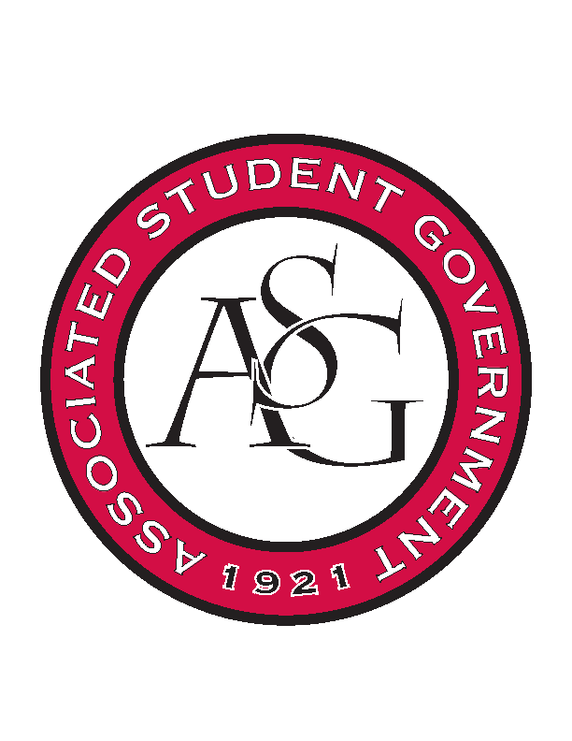
Associated Student Government

Office of Financial Affairs Meeting Minutes
March 14th, 2019

- Call To Order
- Roll Call
  - Adam Corral
  - Alexis Valdes
      - Absent – Proxy: Sally
  - Colin Gonzalez
  - Emily Richey
  - Kirsten James
  - Madeline Brown
  - Ploy Pleetissamuth
  - William Neely
  - Zachary Keating
Proxies
  - Brittany Fulmer
  - Jissel Esparza
      - Absent
  - Kevin Smith
      - Absent
  - Nicholas Foster
      - Absent
  - Sally Gairhan
- Approval of the Minutes
- Appeals
  - Gamma Eta Sorority, Inc.
      - Diversity is a pillar
      - Heroes around the world
      - Canvases to engage students—more interactive & students will take them
      - Inviting with an RSO that is about animal rights
        - Will you be partnering with this RSO?
      - People will write down their hero and why and a polaroid picture will be taken – not a photobooth but a picture station
      - Games provided by the RSO
      - Food will engage students
      - Questions
        - Have you reached out to the RSOs?
          - Yes
        - How would two canvases work? Who will take the canvas after the event?
          - As soon as you are done with the painting, you can take it.
          - Will you be requesting more than 2 canvases?
          - No
      - Motion to vote
        - Approved (9-0)
      - Approved (8-1)
  - Filipino Students Organization
      - Cut because we believed it was a recruitment event
      - “this is not a recruitment event”
      - The purpose is to share the culture and promote the culture to the people on campus and to the Fayetteville community
      - The purchases will be made from Asian Amigo a store here in Springdale
      - Questions
        - Could you walk us through the purpose of the event?
          - The mission of our organization is to promote the culture and provide enrichment of the culture for Pilipino students
          - The halo-halo is a famous desert and students will come in and learn how to make the desert
      - Motion to vote on original budget ($286.00)
        - Approved (9-0)
      - Approved (8-1)
- Tabled
  - Biological Students Association
      - Denied (0-9)
- Old Business
  - Tau Beta Pi
      - Approved (9-0)
  - Residents Interhall Congress
      - Approved (9-0)
- New Business
  - Graduate Society of Women Engineers at the University of Arkansas
      - Late
      - Denied (0-9)
  - Advertising Club
      - Motion to vote on Advertising Club and Public Relations Student Society of America at the same time
        - Approved (9-0)
      - Is this event open to all students?
      - Is this a special meeting/celebration?
      - Denied (0-9)
  - Japanese Student Association
      - What is the significance of the calligraphy? Is it educational?
      - Will you be buying ingredients or pre-made food?
      - Can you provide a quote of what food items that you will be purchasing?
      - Why do you need the tickets?
        - The tickets will be needed to be printed at PMC
      - Denied (0-9)
  - Student Sierra Coalition at the University of Arkansas
      - Approved (9-0)
  - Public Relations Student Society of America
      - Denied (0-9)
  - Christian Legal Society
      - Can you provide a quote for the coffee and donuts?
      - Is this event exclusive to law students?
      - Is this a recruitment event?
      - Denied (0-9)
  - Phi Gamma Delta
      - Approved (9-0)
  - Biology Graduate Student Association
      - Can you provide a quote?
      - Approved (9-0)
  - InterVarsity Christian Fellowship
      - Approved (9-0)
  - Zeta Phi Beta Sorority, Inc.
      - Approved (9-0)
  - Exercise is Medicine
      - We will need to place a sign that states that the prizes were not provided by OFA
      - What do you plan to do if it is raining?
      - Is Pat Walker providing anything?
      - Approved (9-0)
  - Brazilian Student Organization
      - How is the bouncy house and dunk tank educational?
      - If the performers are not students, they will need to provide a performance agreement
      - Admin funds for the poster board
      - Motion to table
        - Approved (9-0)
- Second round of Standing Rules
  - Approved (9-0)
- Audits
  - Contemporary Sculpture Society
      - Colin and Kirsten
  - Do your audits!
- Announcements
- Adjournment

