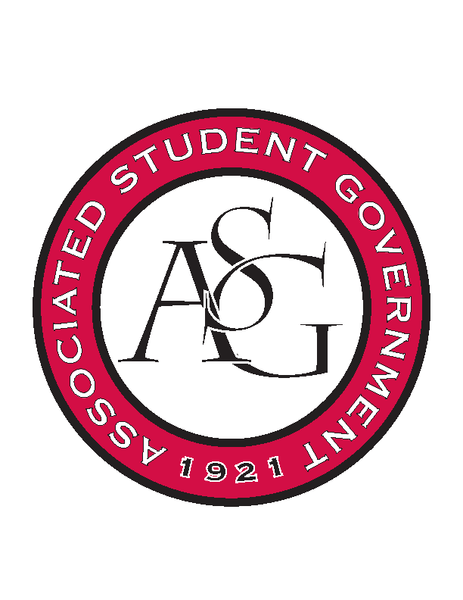
Associated Student Government

Office of Financial Affairs Meeting Minutes
April 11th, 2019

- Call To Order
- Roll Call
  - Adam Corral
  - Alexis Valdes-absent (kevin)
  - Colin Gonzalez
  - Emily Richey
  - Kirsten James
  - Madeline Brown
  - Ploy Pleetissamuth
  - William Neely
  - Zachary Keating
Proxies
  - Brittany Fulmer
  - Jissel Esparza-absent
  - Kevin Smith
  - Nicholas Foster
  - Sally Gairhan
- Approval of the Minutes
- Appeals
- Tabled Budgets
- Old Business
- New Business
  - Razorback Jugglers 0-9 denied
    - Late
    - “it sounds fun”
  - Pi Kappa Alpha 9-0 approved
    - Membership to the organization is much more exclusive than the clubs that we usually deal with; we should question if this is a good use of the student fee money
      - Consider honor societies in the same way
- Audit Reports
  - Korean food night (Nicholas); it was ridiculous that he spoke for ten minutes promoting his company
    - Shani said the repercussions were communicated to him

