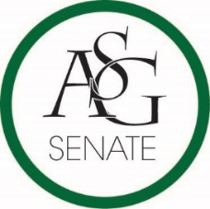
Senate Agenda
September 10th, 2019
Graduate Education Auditorium, 6:30 PM
- Call to Order
- Roll Call
- Approval of the Minutes
- Special Orders
  - Reports (5 minutes each)
    - Special Reports
    - Advisor, PJ Martinez
    - Graduate Assistants, Kelly Fox and Katie Mahar
    - President, Jared Pinkerton
      - Confirmation of Justices
    - Vice-President, Sadie Bryant
    - Treasurer, Kevin Smith Jr.
      - Approval of ASG Budget
    - Secretary, Jack Skidmore
    - Chief Justice, Justyce Yuille
    - GSC President, JD. D’ Loreto
    - Cabinet Reports
      - Chief of Staff, Arianna Kiaei
    - FLF Coordinator, John Hedgecock
    - Chair of the Senate, Kianna Sarvestani
- Appointments, Nominations, and Elections
  - Pro Tempore Nominations
- Public Comment (3 at 2 minutes each)
- Old Business
- New Business
- Announcements
- Adjournment

