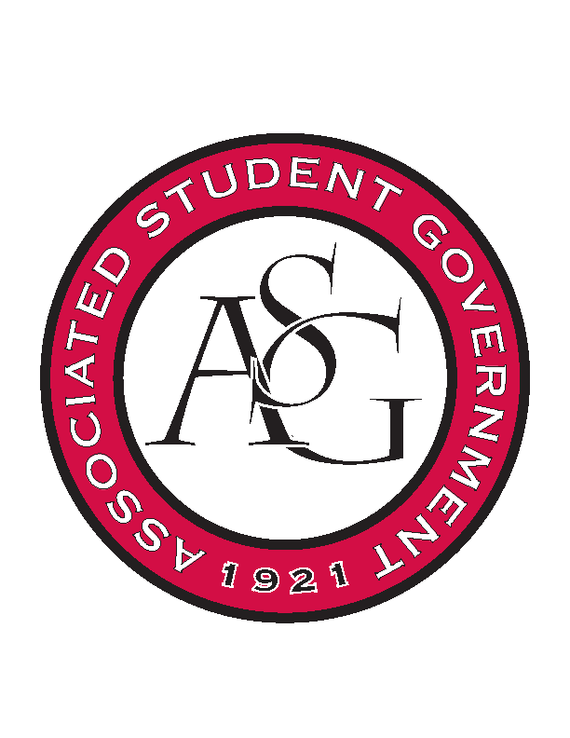
Associated Student Government

Office of Financial Affairs Meeting Agenda
September 5th, 2019

- Call To Order
- Roll Call
  - Madeline Brown
  - Adam Corral
  - Sally Gairhan
  - Kirsten James
  - Christopher Jemison
  - Zachary Keating
  - Elizabeth Kimbrell
  - William Neely
  - Emily Richey
Proxies
  - Denver Eager
  - Jissel Esparza
  - Brittany Fulmer
  - Shalu Jivan
  - Ashylyn Raspberry
- Approval of the Minutes
- Appeals
- Tabled Budgets
- Old Business
  - Society of Hispanic Professional Engineers
  - Arkansas Chemical Engineering Graduate Students
  - Students for Loving Choices
  - Electrochemical Society – University of Arkansas Student Chapter
  - Biology Graduate Student Association
  - Il Circolo Italiano
- New Business
  - Il Circolo Italiano
  - Contemporary Sculpture Society
  - International City Manager’s Association at the University of Arkansas
  - Undergraduate Mock Trials
  - UA Photographic Society
  - The Higher Education Organization
  - American Indian Science and Engineering Society
- Audit Reports

