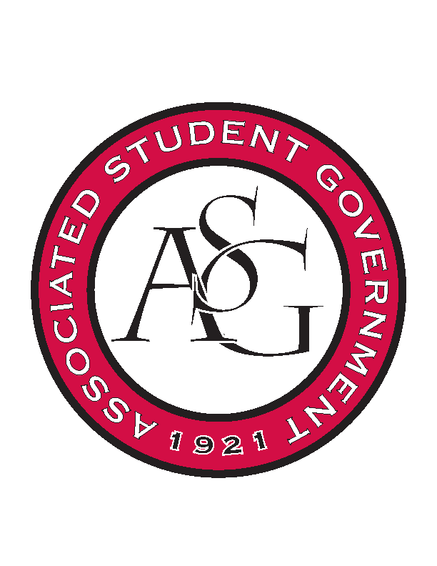
Associated Student Government

Office of Financial Affairs Meeting Agenda
August 29th, 2019

- Call To Order
- Roll Call
  - Brown, Madeline
  - Corral, Adam
  - Gairhan, Sally
  - James, Kirsten
      - Absent
  - Jemison, Christopher
  - Keating, Zachary
  - Kimbrell, Elizabeth
  - Neely, William
      - Absent
  - Richey, Emily
Proxies
  - Eager, Denver
  - Esparza, Jissel
  - Fulmer, Brittany
  - Jivan, Shalu
  - Raspberry, Ashylyn
- Approval of the Minutes
- Introductions
- Expectations
- Binders
- Appeals
- SHPE National Convention 2019
- 9-0 Approved
- AlChe Annual Meeting 2019
- 9-0 Approved
- Students for Loving Choices Administrative Expenses
- 9-0 Approved
- Fall 2019 Kick-Off
      - Questions/Concerns: You need to define a provider for the food, drinks, napkins, etc. As well as how much.
      - Drinks need to be under $1.50 per bottle.
      - They need to send us an invoice.
      - Pizza cannot be over $7.50.
      - You need to review the request with the standing rules.
      - Approved 9-0 with questions
- Biology Graduate Student Association Conference
            - Approved 9-0
- Italian Card Night
      - You said this event is for an educational purpose, but we need more information on how. It needs to be more educational and not just games.
      - How are you sharing the culture with the entire community, but it’s stating there are only 35 people included? That does not seem inclusive with the campus.
- Tabled Budgets
- Old Business
- New Business
  - SHPE National Convention 2019
  - AlChe Annual Meeting 2019
  - Students for Loving Choices Administrative Expenses
  - Fall 2019 Kick-Off
  - Biology Graduate Student Association Conference
  - Italian Card Night
- Audit Reports

