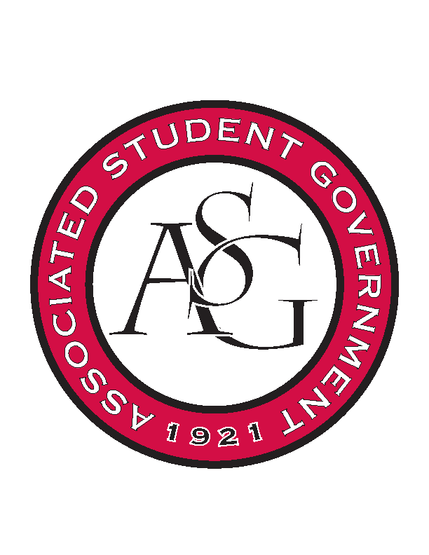
Associated Student Government

Office of Financial Affairs Meeting Agenda
September 5th, 2019

- Call To Order
- Roll Call
  - Madeline Brown
  - Adam Corral
  - Sally Gairhan
  - Kirsten James
  - Christopher Jemison
  - Zachary Keating
  - Elizabeth Kimbrell
  - William Neely
  - Emily Richey
Proxies
  - Denver Eager
  - Jissel Esparza
  - Brittany Fulmer
  - Shalu Jivan
  - Ashylyn Raspberry
- Approval of the Minutes
- Appeals
- Tabled Budgets
- Old Business
  - Society of Hispanic Professional Engineers
      - Approved 9-0
  - Arkansas Chemical Engineering Graduate Students
      - Approved 9-0
  - Students for Loving Choices
      - Approved 9-0
  - Electrochemical Society – University of Arkansas Student Chapter
      - Approved 9-0 with 109.31 with tax
  - Biology Graduate Student Association
      - Approved 9-0
  - Il Circolo Italiano
      - No agenda
      - No funding invoices received about food catering etc., but they may appeal
      - Denied 0-9
- New Business
  - Il Circolo Italiano
      - Why is the hotel is booked for two nights, when the event Is for one day?
      - Why the speaker needs to stay for two nights for a one-day event? Provide flight number as well.
      - How are you sure 100 attendees come with only 31 members? How will you reach out to more students?
      - Provide an agenda for event
      - Audit needed
      - Approved 9-0 with questions
  - Contemporary Sculpture Society
      - Late
      - Denied 0-9
  - International City Manager’s Association at the University of Arkansas
      - Doesn’t cost anything to attend this conference, so clarify what is the funding needed for?
      - We do not fund membership fees
      - Denied 0-9
  - Undergraduate Mock Trials
      - Approved 9-0
  - UA Photographic Society
      - The due date is incorrect
      - Approved 9-0
  - The Higher Education Organization
      - Approved 9-0
  - American Indian Science and Engineering Society
      - Late
      - Denied 0-9
- Audit Reports

