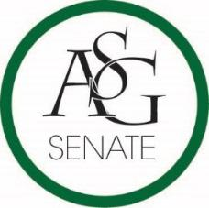
Senate Agenda
October 29, 2019
Graduate Education Auditorium, 6:30 PM

- Call to Order
- Roll Call
- Approval of the Minutes
- Special Orders
  - Reports (5 minutes each)
    - Special Reports
    - Advisor, PJ Martinez
    - Graduate Assistants, Kelley Fox and Katie Mahar
    - President, Jared Pinkerton
    - Vice-President, Sadie Bryant
    - Treasurer, Kevin Smith Jr.
    - Secretary, Jack Skidmore
    - Chief Justice, Justyce Yuille
    - GPSC President, JD. D’Loreto-Hill
    - Cabinet Reports
      - Chief of Staff, Arianna Kiaei
    - FLF Coordinator, John Hedgecock
    - Chair of the Senate, Kianna Sarvestani
- Appointments, Nominations, and Elections
- Public Comment (3 at 2 minutes each)
- Old Business
  - ASG Senate Resolution No. 2- A Resolution to Support Access Pass Equity
    - Author(s): ASG President Jared Pinkerton, ASG Director of Athletics Addison Cathey, Senator Levi Brown
    - Sponsor(s): Senator Brooklyn Warren, Senator Nathan Martinez, Senator Jason Neely, Senator Esteban Lopez, Senator Jacob Spradlin, Senator Stephanie Barber, Senator Anthony Kammerer, Senator Natalie Ceniceros, Senator Beck Williams, Senator Ryan Harra, Senator Bailee King.
- New Business
- Announcements
- Adjournment

