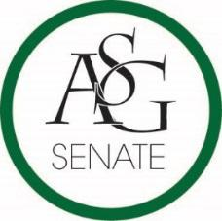
Senate Agenda
November 5, 2019
Graduate Education Auditorium, 6:30 PM

- Call to Order
- Roll Call
- Approval of the Minutes
- Special Orders
  - Reports (5 minutes each)
    - Special Reports
    - Advisor, PJ Martinez
    - Graduate Assistants, Kelley Fox and Katie Mahar
    - President, Jared Pinkerton
    - Vice-President, Sadie Bryant
    - Treasurer, Kevin Smith Jr.
    - Secretary, Jack Skidmore
    - Chief Justice, Justyce Yuille
    - GPSC President, JD. D’Loreto-Hill
    - Cabinet Reports
      - Chief of Staff, Arianna Kiaei
    - FLF Coordinator, John Hedgecock
    - Chair of the Senate, Kianna Sarvestani
- Appointments, Nominations, and Elections
- Public Comment (3 at 2 minutes each)
- Old Business
- New Business
  - ASG Senate Bill No. 2- Bill Clarifying Elections Promotions Committee
    - Authors- ASG Chair of Senate Kianna Sarvestani and Chief Justice Justyce Yuille
    - Sponsors- Senator Cassidy Cook. Senator Natalie Ceniceros
  - ASG Senate Bill No. 3- Bill To Support ASG Tabling at the Union
    - Authors- Senator Ronel Almanza, Senator Lizeth Martinez
    - Sponsors- Senator Katie Long, Senator Angel Meneses, Senator Kate Sego
  - ASG Senate Resolution No. 3: A Resolution to Encourage Mandate of CAPS Information on Syllabi
    - Authors- Senator Ryan Harra, Director of Mental Health Michael Fuhrman
    - Sponsors- Senator Beck Williams
- Announcements
- Adjournment

