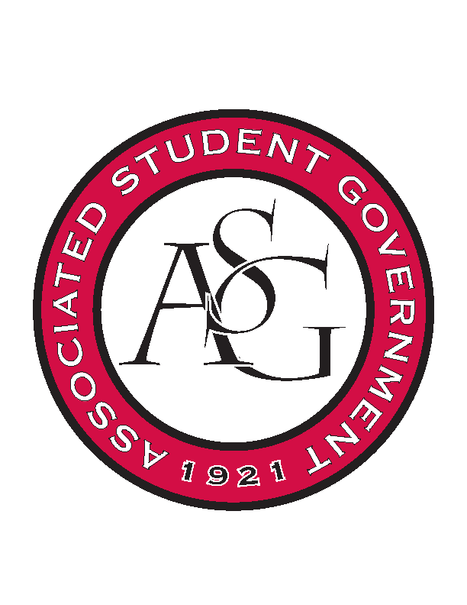
Associated Student Government

Office of Financial Affairs Meeting Agenda
October 31st, 2019

- Call To Order
- Roll Call
  - Madeline Brown
  - Adam Corral
  - Sally Gairhan
  - Kirsten James
  - Christopher Jemison
      - Absent
  - Zachary Keating
  - Elizabeth Kimbrell
  - William Neely
  - Emily Richey
Proxies
  - Denver Eager
      - Proxy
  - Jissel Esparza-
  - Brittany Fulmer
  - Shalu Jivan
  - Ashlyn Rasperry
      - Proxy
- Approval of the Minutes
- Appeals
- Tabled Budgets
- Old Business
      - Chinese Student Scholars
- Approved 9-0
      - Chi Alpha
- Requested documentation was provided
- Approved 9-0
- New Business
      - Razorback Jugglers
- Late
- Denied 0-9
      - Biology Graduate Student Association
- Late
- Denied 0-9
      - Advertising Club
- Based on your description this seems like a networking event. Justify how this event will be educational and is not an networking event? (Standing Rules-Line 254)
- Approved 7-2
      - Christian Legal Society
- How do you plan to make this event inclusive to the student body?
- Late
- Denied 0-9
      - Christian Legal Society
- How do you plan to make this even inclusive to the student body?
- Late
- Denied 0-9
      - Kappa Delta Pi
- Late
- Denied 0-9
- Audit Reports

