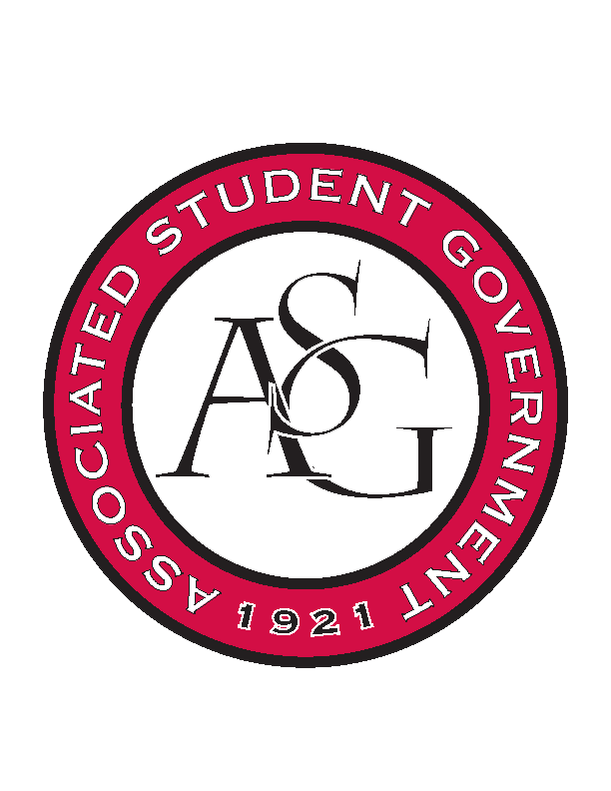
Associated Student Government

Office of Financial Affairs Meeting Agenda
November 14th, 2019

- Call To Order
- Roll Call
  - Madeline Brown
  - Adam Corral
      - Jissel - Proxy
  - Sally Gairhan
  - Kirsten James
  - Christopher Jemison
  - Zachary Keating
  - Elizabeth Kimbrell
  - William Neely
  - Emily Richey
Proxies
  - Denver Eagar
  - Jissel Esparza
      - Proxy
  - Brittany Fulmer
  - Shalu Jivan
  - Ashlyn Rasberry
- Approval of the Minutes
- Appeals
      - Advertising Club
- Approved 9-0
- Tabled Budgets
- Old Business
      - Kappa Delta Pi
- Approved 9-0
      - Black Law Students Association
- Motion to cut to $450, Approved 9-0
- Approved 9-0
- New Business
      - Kappa Alpha Psi Fraternity, Inc.
- We cannot process a conference after it occurred.
- Denied 0-9
      - Alpha Kappa Psi
- Can you please change the date to the regular pricing that ends on January 20th (next Wednesday by 5PM)?
- You need to change the date, price per person, & the exact number of people
- Approved 9-0 with questions
      - Law Young Democrats
- Denied 0-9, we do not fund meetings
      - Phi Delta Theta
- Approved 9-0
      - Undergraduate Mock Trial
- You need to send us a confirmed pricing
- Approved 9-0
      - Chinese Students and Scholars Association
- The food budget doesn’t indicate exactly how much catering we are funding.
- The added $1000 affects multiple aspects of the event such as ticketing.
- You will need to revise the event date when resubmitting.
- Denied 0-9
- Audit Reports

