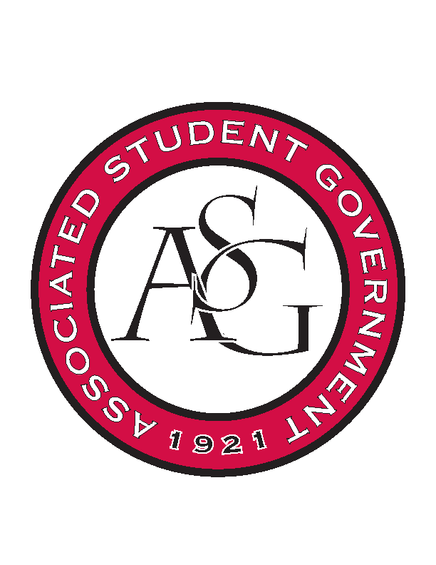
Associated Student Government

Office of Financial Affairs Meeting Agenda
November 7th, 2019

- Call To Order
- Roll Call
  - Madeline Brown
  - Adam Corral
  - Sally Gairhan
  - Kirsten James
  - Christopher Jemison
  - Zachary Keating
  - Elizabeth Kimbrell
  - William Neely
  - Emily Richey
Proxies
  - Denver Eagar
  - Jissel Esparza
  - Brittany Fulmer
  - Shalu Jivan
  - Ashlyn Rasperry
- Approval of the Minutes
- Appeals
- Tabled Budgets
- Old Business
      - Advertising Club
- Denied 0-9, They did not respond back to the questions.
- New Business
      - Kappa Delta Pi
- Approved 9-0
      - Black Law Students Association
- The link provided only verifies the $75 registration fee.
- You need to provide us with the full conversion of the email. You can forward the email chain to us.
- If you choose to give away monetary prizes, this should be provided through your RSO’s funding.
- Provide the email that defines the due date and defines the fees.
- Provide us with details on verifications on when each individual fee is due.
- Approved 9-0 with Questions
- Audit Reports

