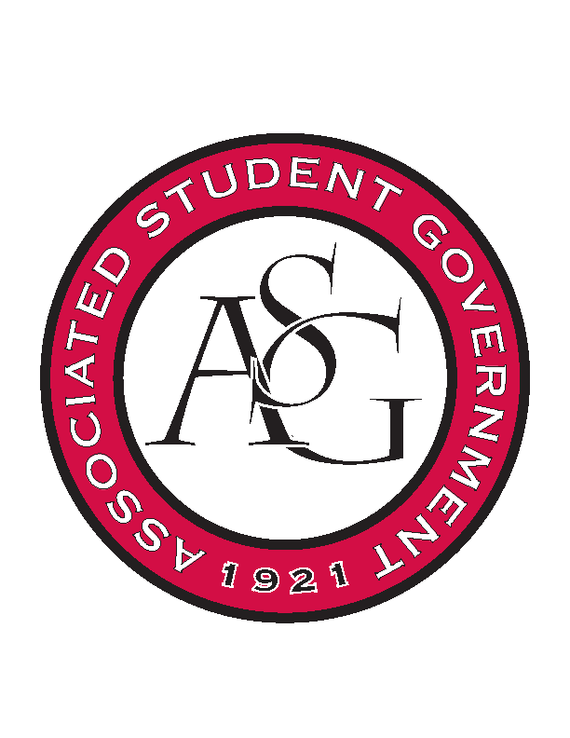
Associated Student Government

Office of Financial Affairs Meeting Agenda
November 21st, 2019

- Call To Order
- Roll Call
  - Madeline Brown
      - Absent
  - Adam Corral
  - Sally Gairhan
  - Kirsten James
  - Christopher Jemison
      - Absent
  - Zachary Keating
  - Elizabeth Kimbrell
  - William Neely
  - Emily Richey
Proxies
  - Denver Eagar
      - Absent
  - Jissel Esparza
  - Brittany Fulmer
  - Shalu Jivan
      - Absent
  - Ashlyn Rasberry
- Approval of the Minutes
- Appeals
- Tabled Budgets
- Guest Speakers
      - Mainhill Media
- Old Business
      - Alpha Kappa Psi
- Updated date (January 20th) was provided
- Approved 9-0
      - Phi Delta Theta
- Approved 8-0
      - Undergraduate Mock Trial
- Verification of the prize (Trophy) was provided
- Approved 9-0
- New Business
      - Apostolic Campus Ministries
- Event has already occurred
- Denied 0-9
      - Non-traditional Premedical Student Organization
- Only exclusive to 6 students and the location cannot be “TBD”
- Denied 0-9
      - Association of Ceramic Enthusiasts
- Approved 9-0
      - Contemporary Sculpture Society
- We perceive this event as a networking event, rather than an educational event. Is your purpose primarily networking?
- You need to provide an itinerary.
- Approved 9-0 with Questions
      - Eta Sigma Phi-Beta Pi
- Motion to cut 1 hotel night, 1 per diem, and the Petra lunch seminar
- Approved 9-0 with cuts
- Audit Reports

