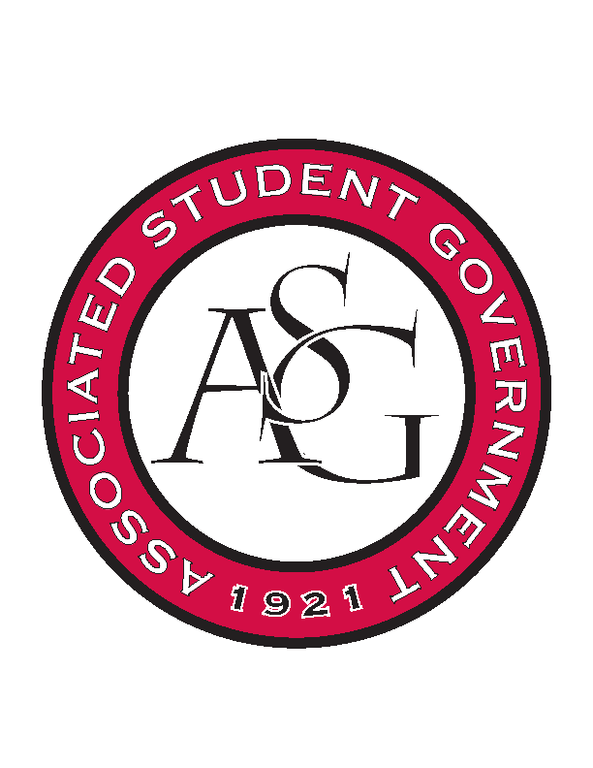
Associated Student Government

Office of Financial Affairs Meeting Agenda
December 5th, 2019

- Call To Order
- Roll Call
  - Madeline Brown
  - Adam Corral
  - Sally Gairhan
  - Kirsten James
  - Christopher Jemison
  - Zachary Keating
  - Elizabeth Kimbrell
  - William Neely
  - Emily Richey
      - Jissel
Proxies
  - Denver Eager
  - Jissel Esparza
  - Brittany Fulmer
      - Absent
  - Shalu Jivan
  - Ashlyn Rasperry
- Approval of the Minutes
- Appeals
- Tabled Budgets
- Old Business
      - Contemporary Sculpture Society
        - Approved (7-0)
      - Eta Sigma Phi – Beta Pi Chapter
        - Clarification on the agenda
        - What is happening at the lunch, Tiny Tim’s, and the event?
        - Can Tiny Tim’s be delivered?
        - Which events are open to all students? Which events are private?
        - Motion to table
          - Approved (7-0)
      - Association of Ceramic Enthusiasts
        - Approved (7-0)
- New Business
      - Christian Graduate Student Fellowship
        - Tentative details (speaker)
        - Denied (0-9)
      - Chinese Students and Scholars Association
        - Invoice needs to be for 215 people, not 300
          - Add in after ticket sales if they sell tickets for other people
        - Can you provide an itinerary?
        - Approved (9-0)
      - Collegiate Percussive Arts Society
        - Can you provide an agenda?
        - Approved (9-0)
      - Developer Student Club at the University of Arkansas
        - Approved (9-0)
- Audit Reports
  - Chinese Students and Scholars
  - Muslima

