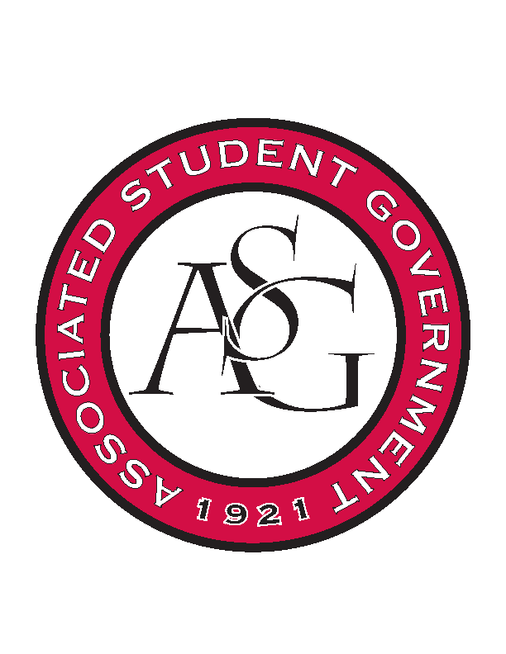
Associated Student Government

Office of Financial Affairs Meeting Agenda
December 12th, 2019

- Call To Order
- Roll Call
  - Madeline Brown
  - Adam Corral
  - Sally Gairhan
  - Kirsten James
  - Christopher Jemison
      - Absent
  - Zachary Keating
  - Elizabeth Kimbrell
  - William Neely
  - Emily Richey
Proxies
  - Denver Eagar
  - Jissel Esparza
      - Absent
  - Brittany Fulmer
  - Shalu Jivan
      - Proxy Christopher
  - Ashlyn Rasberry
- Approval of the Minutes
- Appeals
- Tabled Budgets
      - Eta Sigma Phi- Beta Chapter
- Motion to cut reception at Tim’s Pizza, Approved (7-2)
- Approved (9-0)
- Old Business
      - Chinese Students and Scholars Association
- Itinerary and Invoice was provided
- Approved (9-0)
      - Collegiate Percussive Arts Society
- Itinerary was provided
- Approved (9-0)
      - Developer Student Club at the University of Arkansas
- Approved (9-0)
- New Business
      - Vietnamese Students Association
- Denied (0-9) Standing Rules Line 284
      - Christian Graduate Student Fellowship
- Be sure to advertise to the campus community, so that it’s open to all students and Inclusive
- Approved (9-0)
      - Pi Tau Sigma
- Late
- Denied (0-9)
      - Society of Hispanic Professional Engineers
- This RSO has already reached their allocation limit for the 2019-2020 year
- Late
- Denied (0-9)
      - Scribes: UARK Poet Society
- Approved (9-0)
- Audit Reports

