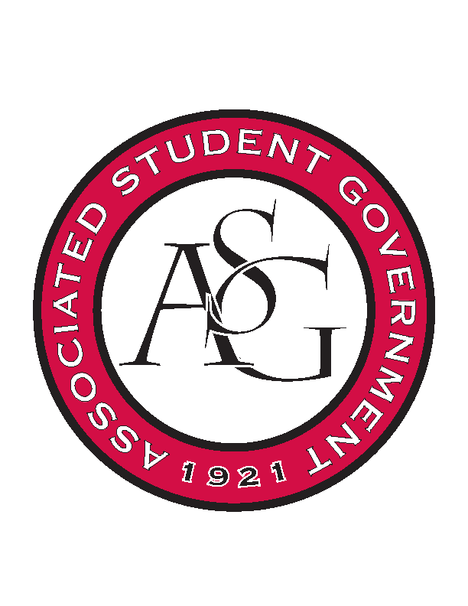
Associated Student Government

Office of Financial Affairs Meeting Minutes
January 30th, 2019

- Call To Order
- Roll Call
  - Adam Corral
      - Absent
  - Sally Gairhan
  - Kirsten James
  - Christopher Jemison
  - Zachary Keating
      - Absent
  - Elizabeth Kimbrell
  - William Neely
  - Emily Richey
      - Absent
Proxies
  - Denver Eagar
  - Jissel Esparza
  - Brittany Fulmer
  - Shalu Jivan
  - Ashlyn Rasberry
- Approval of the Minutes
- Appeals
- Tabled Budgets
- Old Business
      - Geo-Institute Graduate Student Organization
        - Approved (9-0)
      - Millicent Gikunda
        - Approved (9-0)
      - The Collegiate Alliance of Theatrical Students
        - Approved (9-0)
      - UA Photographic Society
        - Approved (9-0)
      - Minorities in Agriculture, Natural Resources, and Related Sciences
        - Approved (9-0)
      - Muslim Students Association
        - You will need permission from housing to hang fliers in dorms
        - Motion to add tickets
          - Approved (9-0)
        - 2:1 student to non-student ration
          - You can have a maximum of 50 non-students with 100 students in attendance
          - Please focus more on reaching out to students rather than non-students
          - If non-students do not have tickets, they cannot eat
        - We will be auditing the event
        - Approved (9-0)
      - Kappa Alpha Psi Fraternity, Inc.
        - Approved (9-0)
      - Biology Graduate Student Association
        - Approved (9-0)
      - Black Graduate Student Association
        - Approved (9-0)
      - Students Advocating Stronger Sisterhood
        - Approved (9-0)
      - Inspire
        - Approved (9-0)
      - Students Advocating Stronger Sisterhood
        - There will need to be a sign placed by the prizes stating that the prizes were not funded by OFA
        - Market to men as “women’s ally”
        - We will audit all events throughout the week
          - Remind OFA members

        - Approved (9-0)
- New Business
      - First Baptist Church Fayetteville Collegiate Group
        - Late
        - Denied (0-9)
      - American Society of Civil Engineers
        - Late
        - Denied (0-9)
      - Alpha Gamma Rho
        - Late
        - Denied (0-9)
      - CRU
        - Line 297 – we cannot fund local travel
        - Motion to cut one day of per diem, 2 nights hotel, and $50 from travel expense (gas)
          - Approved (9-0)
        - Approved (9-0)
      - Electrochemical Society – University of Arkansas Student Chapter
        - Recruitment Event
        - Approved (9-0)
      - Walton College Finance Association
        - Approved (8-0)
      - Walton College Finance Association
        - Approved (9-0)
      - UARK Music Performers Producers & Professionals
        - Can you provide an itinerary of the event?
        - Remind OFA to audit (maybe shifts because the event is 8 hours)
        - Approved (9-0)
      - Students Demand Action
        - Please include emails of Sydney Golding and Reed Ostner
        - What will you be doing at the conference? Is this different from lobbying legislators?
        - Motion to cut conference to $205
          - Approved (9-0)
        - Approved (7-2)
      - CEO Global at the University of Arkansas
        - Approved (9-0)
      - Russian-Eurasian Student Organization
        - Is the lunch (food) at Hill Coffee open to all students?
        - Motion to cut the hotel to one night
          - Approved (8-1)
        - What are the dates of the flight?
        - Approved (9-0)
      - Graduate Students in English
        - How many non-University of Arkansas students do you anticipate attending in total? How many University of Arkansas students do you anticipate attending in total?
        - How do you plan to increase your University of Arkansas student attendance from last year, from 21 to 75?
        - Is this exclusive?
        - Two days before SB
        - Motion to table
          - Approved (9-0)
- Audit Reports

