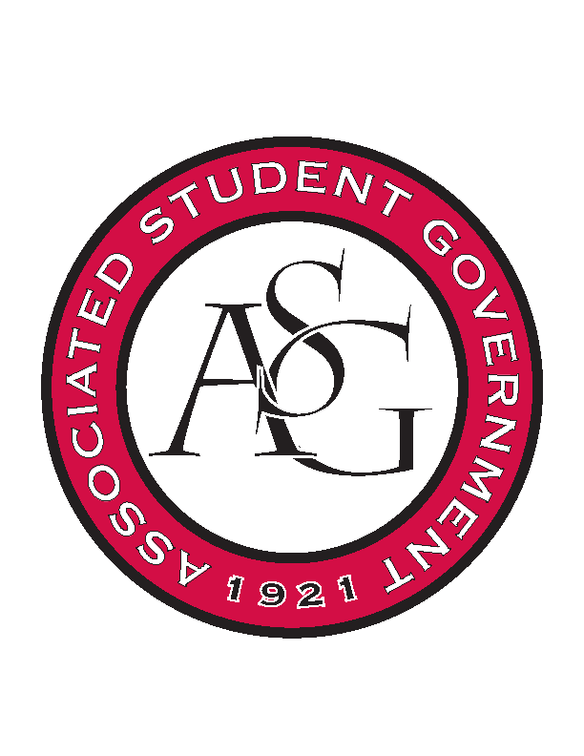
Associated Student Government

Office of Financial Affairs Meeting Minutes
February 6th, 2019

- Call To Order
- Roll Call
  - Adam Corral
  - Sally Gairhan
      - Absent, Brittany
  - Kirsten James
      - Absent, Shalu
  - Christopher Jemison
  - Zachary Keating
  - Elizabeth Kimbrell
  - William Neely
  - Emily Richey
  - Denver Eager
Proxies
  - Jissel Esparza
  - Brittany Fulmer
      - Proxy
  - Shalu Jivan
      - Proxy
  - Ashlyn Rasberry
- Approval of the Minutes
- Appeals
- Tabled Budgets
- Presentations
      - Iranian Students Association
- Provide us with an itinerary/agenda
- Provide us with an outline of the presentations
- Approved 9-0 w/ Question
- Old Business
      - CRU
- Approved 9-0
      - Electrochemical Society
- Approved 9-0
      - Walton College Finance Association
- Approved 8-0
      - Walton College Finance Association
- Approved 8-0
      - UARK Music Performers Producer & Professionals
- Approved 9-0
      - Students Demand Action
- Approved 9-0
      - CEO Global at the University of Arkansas
- Approved 9-0
      - Russian-Eurasian Student Organization
- Motion to cut coffee $60, Approved 9-0
- Approved 9-0
      - Graduate Students in English – move new
- Tickets are for the non-students, not UARK students. How many non-students do you anticipate attending the event?
- What would you do if a non-english student attended?
- What is the plan for a student who hasn’t submitted written works, but is interested to attend your event?
- How to you plan to make this event inclusive to non-english students.
- Denied 1-8
- New Business
      - Saxophone Society at the University of Arkansas
- Can you confirm the registration fee? There seems to be a price increase.
- Approved 9-0
      - Space and Planetary Association for Collaboration and Education Hogs
- Provide us with an itinerary?
- How to you plan to promote the event? Market plan?
- Approved 9-0
      - Institute of Industrial and Systems Engineers
- Provide a screenshot or proof of confirmation for the conference?
- Approved 8-0
      - Bangladesh Student Organization
- We cannot fund all of the food for the amount it is at right now. Can you decrease or revise the price by .85 cents per person.
- Look at Sam’s Club prices for the utensils.
- Approved 9-0
      - Vietnamese Students Association
- Provide a confirmation of the conference date, as well as the price for that date?
- Approved 9-0
- Audit Reports

