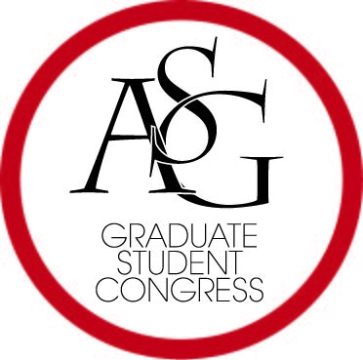
Associated Student Government
University of Arkansas

ASG Joint Bill 8
2016-2017

Restore Rights to Students Act of 2017

Author(s): ASG Senator Scott Sims, GSC Vice Speaker Arley Ward
Sponsor(s):

Whereas, the ASG Constitution, Article VI, Section 3 states that “the general ASG membership shall have the authority to initiate the amendment process”; and

Whereas, the ASG Code, Title IX, Section 1 details the Student Initiative Process; and

Whereas, Title IX, Section 1: Student Initiative Process effectively denies the general ASG membership of the right to initiate amendments by requiring the entire process, including approval and signature acquisition, to occur in the Spring semester; then

Be it therefore enacted: Title IX, section C be amended to the following:

“C. After the title and statement of purpose have been approved, the author of the initiative has until three (3) weeks prior to any ASG Election to gather the required number of signatures and to submit the petitions to the OSA to determine the validity of each signature.”

Be it further enacted: Title IX, section E be amended to the following:

“E. Initiatives are valid one calendar year after the title and statement of purpose are approved by the ASGJ.”

Official Use Only

Amendments:

Vote Count: Aye _ Nay _ Abstentions

Legislation Status: Passed Failed _ Other

___________________________ ________________
Scout Johnson, ASG GSC Speaker Date

___________________________ ________________
Will Watkins, ASG Chair of Senate Date

___________________________ ________________
Connor Flocks, ASG President Date

