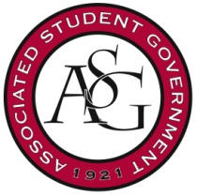
Associated Student Government
University of Arkansas

ASG Senate Resolution No. 8
Author(s): Senator J.P. Gairhan
Sponsor(s): Senator Colman Betler, FLF Member Maria Calderon

Resolution in Support of the Student Government Initiative to Preserve Senior Walk

Whereas, The University of Arkansas has maintained a “Senior Walk” for well over one hundred years and that very tradition has been unique to the university until recently, and

Whereas, Certain portions of Senior Walk on campus have fallen into disarray over time, with cracks and blemishes making it hard to discern what names are being displayed, and

Whereas, There is a university-wide effort towards a new program called the save senior walk initiative that would go towards proper renovation and maintenance of the oldest sections of our Senior Walk, and

Whereas, The current ASG Executive Committee ran on a promise to move towards the same policy currently being enacted by the administration.

Let it be therefore resolved, The Associated Student Government Senate supports the administrative efforts being put towards securing the longevity of our Senior Walk tradition,

Be it finally resolved, The Associated Student Government Senate seeks to assist that programming in whatever way possible, bridging communication between our administration and its students.

Official Use Only

Amendments:

Vote Count: Aye Nay Abstentions

Legislation Status: Passed Failed Other

___________________________ ________________
Will Watkins, ASG Chair of the Senate Date

___________________________ ________________
Connor Flocks, ASG President Date

