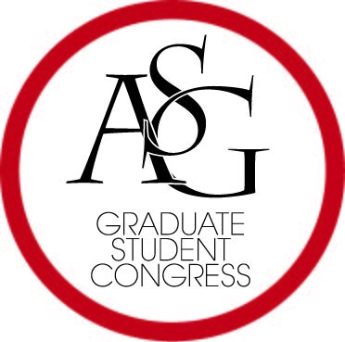
Graduate Student Congress
Associated Student Government
University of Arkansas

Inauguration Meeting Minutes
Date – September 20, 2017
Graduate Education Auditorium, 6:00-8:00 pm

ATTENDING: Aguilar, Ames, Beals, Belote, Birch, Bohlen, Braddock, Brooks, Burbridge, Callahan, Cervellere, Conrad, Diaz, DiLoreto, Dougherty, Dye, Ehlers, Elkin, Jeter, Kimbrough, Koshkarbaeva, Marcon, Marino, Miller, Moore, Nardo, Nuun, Oramous, Ravishankar, Rowlett, Sturdivant, Sumler, Taylor, Tidwell, Ward, Whiting. Guests: Joseph Daniels, Cory English, ASGJ Chief Justice. Absent: Abdalhadi, Atkins (ill), Bakare (teaching), Blanchard (acad/prof), Boyd, Gamage, Kaijage (prof/acad), Morse, Scot, Whitehead, Wilbanks, Wilkinson.

- Call to Order: 6:17 pm.
- Attendance. Quorum met.
- Approve Agenda. Motion. 2nd. Approved.
- Approve Minutes. Motion. 2nd. Approved.
- Swearing in of new fall-vacancy elected representatives (WARD)
VI. Approval of Judicial Appointments: Cory English presented 5 nominees for Associate Justice or proxy: Brandon Turner, Spencer George, Pierce Tieling, Cassidy Curtis (p), Ben Waddell (p). Questioning of each transpired.

Marino: MOTION to vote by acclamation as a block.
Vote on motion: 28 yes, 9 no. Vote by acclamation. Approved.

VII. State of Graduate Students Address (WARD)

VIII. Public Comment. None.

IX. Announcements
1. Ward: Meet the GSC Social delayed till 9/27/17

X. Adjourn. MOTION. 2nd. 6:59 pm.

SUBMITTED FOR REVIEW,

Garrett C. Jeter

Garrett C. Jeter
Recording Secretary

