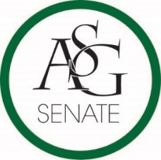
Senate Agenda
September 26th , 2017
Graduate Education Auditorium, 6:00 PM
- Call to Order
- Roll Call
- Approval of the Minutes
- Special Orders
  - Reports (5 minutes each)
    - Special Reports
      - Anna Kay Hilburn
      - J.P. Gairhan
    - Advisor, Michael McAllister
    - Graduate Assistants, Joshua Saraping and Sage McCoy
    - President, Andrew Counce
    - Vice-President, Natalie Counce
    - Treasurer, Macarena Arce
    - Secretary, Ashton Yarborough
    - Chief Justice, Cory English
    - GSC Speaker, Arley Ward
    - Cabinet Reports
      - Chief of Staff, JT Hale
    - FLF Coordinator, Abigail Walker
    - Chair of the Senate, Colman Betler
- Appointments, Nominations, and Elections
- Public Comment (3 at 2 minutes each)
- Old Business
  - ASG Joint Resolution N0. 2 – Arkansas Union Food Court Expansion Act
    - Authored by Senator Josie DuBois, Director of External Relations Trevor Villines
    - Sponsored by GSC Representative Caleb Conrad, Senator Brittany Smith
- New Business
  - ASG Resolution N0. 2 - A Resolution to Reaffirm the Role of the Freshman Leadership Forum
    - Authored by Senator Drake Moudy, Senator Jesse Kloss, FLF Coordinator Abigail Walker, and Chairwoman Maria Calderon of the Associate Member Program
    - Sponsored by Senator Jesse Kloss, Senator Clay Smith, Senator Caroline Dallas
- Announcements
- Adjournment

