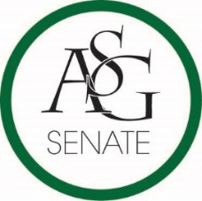
Senate Agenda
October 4th , 2016
WJWH Room 427 Auditorium, 6:00 PM
- Call to Order
- Roll Call
- Approval of the Minutes
- Special Orders
  - Reports (5 minutes each)
    - Special Reports
    - Advisor, Michael McAllister
    - Graduate Assistants, Katherine Selman and Katie Martens
    - President, Connor Flocks
    - Vice-President, Maggie Benton
    - Treasurer, Shelby Cormack
    - Secretary, Jase Rapert
    - Chief Justice, Cory English
    - GSC Speaker, Scout Johnson
    - Cabinet Reports
      - Chief of Staff, Taylor Farr
    - FLF Coordinator, Kyle Ward
    - Chair of the Senate, Will Watkins
- Nominations and Elections
- Public Comment (3 at 2 minutes each)
- Old Business
- New Business
- Meetings
  - Committee Meetings
- Announcements
- Adjournment

